MOODIFY: A MOOD-TRACKING MOBILE APPLICATION WITH EMOTIONAL REGULATION TOOLS



A Capstone Research Project Presented to
The Senior High School Department of
Malayan Colleges Mindanao

Abdon, Christian Jay P.
Lopez, Maria Rafaella A.
Magoncia, Sydrick F.
Maño, Krychelle Mitch B.
Morancil, Brandy Babe B.
Nemenzo, Janine Bernadette L.
Nor, Khushtav Marcus Ciel P.
Roque, Johann D.

January 2026
CHAPTER 1

INTRODUCTION

Background of the Study
Mental health is increasingly recognized as a critical global issue, with the World Health Organization estimating that one in four individuals will experience a mental health condition during their lifetime (WHO, 2022). Central to mental well-being is emotional awareness, the capacity to identify, understand, and manage one’s emotions which has been linked to improved stress coping, decision-making, and overall psychological resilience. Despite the proliferation of mood-tracking applications, many focus primarily on recording moods rather than facilitating reflection on underlying causes or actionable strategies for emotional regulation (Fleming et al., 2018; Torous et al., 2018). In the Philippine context, mental health awareness and emotional literacy are emerging priorities, particularly among adolescents and young adults facing academic, social, and familial pressures (Department of Health, 2020). However, accessible tools that promote reflective emotional practices remain limited. Developing a mobile platform that not only monitors daily emotions but also encourages insight into triggers, contexts, and personal responses can therefore support deeper emotional understanding and foster proactive mental health management.
Emotions influence mood, and mood shapes how emotions are experienced. Emotional awareness is the ability to recognise and make sense of not just your own emotions, but also those of others. High levels of emotional awareness means you can learn from your feelings quickly. For example, if you feel sad, you can reflect on why this is so, and make decisions that then help you. It also means you can predict emotions in advance – you know what actions will lead to what emotions, and this means you can make better choices accordingly (Darcy & Jacobson, 2023). Mental health is a vital component of overall health and wellness, as awareness and early recognition of symptoms play a key role in seeking timely help. According to Philippine Psychiatric Association President Dr. Joan Mae Rifareal, recognizing signs such as persistent sadness, loss of interest, sleep or appetite changes, and difficulty concentrating is important. She emphasized that conditions like depression and anxiety are legitimate medical disorders with scientific bases affecting emotions, physical health, and cognitive functioning, and that reducing stigma is essential to encourage individuals to seek support (Montemayor, 2025). By 2025, the Philippines has rapidly transformed its information technology landscape from lagging in digital infrastructure to emerging as a key digital player in Asia. This growth has been driven by government support, an increasingly tech-savvy young population, and rising foreign investment, positioning the country for continued innovation and digital development (Insight Success Magazine, 2025). Mobile applications have become essential in everyday life, yet many still lack meaningful and emotionally engaging user experiences. While technology continues to advance, personalization in most apps remains limited to basic data patterns, resulting in generic and uninspiring interactions. As user needs evolve, future applications must adopt more empathetic and context-aware approaches to deliver genuine value and address unmet human needs (Sarraf, 2025).
Mood-tracking features have been incorporated into the mobile mental health support applications that are now in the market and mainly developed for the users' benefit, especially students. The research by (Hamre-Os, 2021) demonstrated that people could use mood-tracking interfaces to keep records of their feelings and then view these records over a certain period, while (Jimu and Mwakiseghire, 2024) insisted that the combination of mood tracking with mental health resources is a potentially powerful method for facilitating emotional awareness via mobile technology. However, even with these advances, a significant void still exists in the society since most of the current applications are mainly concerned with mood logging and give little, if any, support in helping the users to identify emotional triggers, the factors in the situation, or the right coping methods. This issue is even more pronounced in the Philippines, a country where mental health problems are a major issue and people who need help often find it hard to get such, particularly those who live in the rural and non-urban areas, thus, leaving them with very few means to cope with their daily mental health problems (World Health Organization, 2021). Hence, the project intends to create a mobile application that provides mental health support and has mood tracking, integrated resources that not only capture user’s feelings but also promotes the exploration of the psychological, daily, and emotional aspects, while at the same time providing easy to access self-help resources and guidance. By doing so, the system is expected to foster emotional awareness, bolster the management of mental health, and offer a real, technology-based remedy that is in tune with the increasing mental health students' needs and for the broader Philippine community.

Project Objectives
The objective of this study is to aid individuals in improving their understanding of their own emotions and managing them efficiently by developing a mood tracking application that includes emotional regulation tools. The specific objectives of the project are as follows:

1. To design and develop a prototype mood tracking application with emotional regulation tools that allows users to use it on a regular basis.
2. To evaluate the application's performance in terms of:
a. Functionality
b. Usability
c. Reliability
d. Performance
e. Supportability
3. To assess users’ user experience after using the mood-tracking application.

Significance of the Study
Students and young individuals. Moodify primarily benefits students and young individuals who experience daily emotional fluctuations and mood changes. Moodify provides them with an accessible and user-friendly platform to track multiple emotions, reflect on emotional triggers, and practice basic anxiety management techniques such as breathing exercises and calming activities.

Educational Institutions. Moodify benefits educational institutions by serving as a supportive digital tool that can complement mental health awareness and wellness programs. Schools and universities may use the findings of this study as a reference for promoting emotional well-being among students through non-clinical, technology-based solutions.

Developers and Mental Health App Designers. This study is significant for developers and designers of mental health applications as it provides insights into user preferences, system quality factors, and the effectiveness of integrating multi-mood tracking with reflective prompts and anxiety tools. The results may guide future improvements in the design of user-centered digital mental health solutions focused on everyday emotional support rather than clinical intervention.

Future Researchers. The study serves as a valuable reference for future researchers interested in digital mental health, mood tracking, and emotional awareness. It contributes to existing literature by examining a non-clinical, mobile-based mood tracking application and may serve as a foundation for further studies on long-term usage, expanded features, or broader populations.

Scope and Delimitation of the Study
This study focuses on the design, development, and evaluation of Moodify: A Mood tracking Mobile Application with Emotional Regulation Tools,. This application is intended to support users in monitoring their daily emotions and improving emotional awareness through multi-mood logging, reflective prompts, diary-style entries, and basic emotional regulation tools such as breathing exercises and calming activities.
The scope of the research includes the assessment of the application’s functionality, usability, reliability, performance, and supportability, as well as its perceived benefits in enhancing emotional self-awareness and regulation through self-monitoring. The study is limited to general users, particularly students and young individuals experiencing everyday emotional fluctuations, and does not aim to diagnose, treat, or replace professional mental health services.
Furthermore, the anxiety tools included are non-clinical and self-guided, the evaluation is conducted over a short-term usage period with a limited number of participants, and the development is confined to a mobile application prototype, excluding long-term psychological effects, clinical populations, and other platform implementations.

Related Literature
Mood and Emotion Tracking
Mood and emotion are psychological states that change and influence how an individual may react and perceive a certain situation. According to Malek Mneimi (2020), emotion is defined as short-lived and intense responses to a tangible stimulus that is built up of one's thoughts, changes in normal functions of the body, and behaviour, which differentiates emotion from mood. Mood can be considered as an emotion that no longer serves as an adaptive function. It is long-lasting and a chronic response to a potential stimulus that is often unidentifiable as it is shaped by one's environment, diet, body, and mind (Miller, & Olsson, 2022). In a psychological sense, a mood helps individuals find themselves in the world, as moods constitute different possibilities of how things are able to matter to one (Ratcliff, 2013). Both of these concepts are closely related, essentially shaping a person's overall emotional experience. Understanding the distinction between the two will provide a foundation that helps explain the behavioural responses and clarify how they affect overall well-being.
Furthermore, mood and emotion have proven to affect mental well-being. It is explained by Brett Ford & Iris Mauss (2026) that emotions, specifically the intensity, fluctuation, and context of them, influence behaviour and cognition. Intense positive emotions make an individual more likely to engage in risky activities, while negative emotions, such as fear in the context of being in a dangerous situation, help one notice and avoid threats. Additionally, high fluctuation in emotion may be linked to low mental health. This is supported by Chen et al. (2018) and Shahzad et al. (2021), who reported that emotion-related expressions reflect one's psychological state and proved that low mental health could link to mental health problems. In relation to this, research shows that tracking your mood regularly and reflecting upon it can facilitate self-awareness and understanding of your emotions, leading to a lower risk of low mental health (Schueller et al., 2021). Digital mental health tools such as mood tracking applications are essential for self-management. Not only that, but it is more reliable in terms of data accuracy.
Research exploring mood tracking and emotional monitoring apps shows that digital systems can significantly support users’ understanding of their emotional lives and promote mental well‑being. Feature analyses of commercially available mood tracking applications found that users regularly engage with these tools to identify mood patterns, reflect on emotional changes, and self‑manage aspects of their mental health, aligning with the idea that tracking mood over time can make latent emotional trends visible and meaningful (Schueller et al., 2021). Such studies indicate that regular engagement with mood tracking tools can reduce symptoms of depression and anxiety and increase emotional self‑awareness, highlighting how consistent monitoring can be beneficial for mental health outcomes (Dubad et al., 2021). Furthermore, systematic reviews of mental health apps that include mood monitoring components suggest that these digital tools have small to moderate positive effects on well‑being, emotion regulation, and symptoms of stress, depression, and anxiety in general populations, demonstrating that technological monitoring translates theoretical concepts (Eisenstadt et al., 2021). These findings suggest that mood tracking applications do not merely collect data; they can actively aid users in recognizing and responding to psychological changes, reinforcing their value in mental health self‑management.
In addition to basic mood tracking, more advanced systems integrate real‑time feedback, physiological data, and predictive analytics to enhance emotional insight and mental health support. For example, apps that combine wearable activity tracking with mood monitoring provide continuous data on behaviour and states, allowing users and clinicians to observe correlations between mood, sleep, and activity patterns, which can inform personalized strategies for emotional stability (Adigun, & Adelusi, 2024). These technologically enhanced systems underscore the relationship between mood, emotion, and psychological well-being by demonstrating that ongoing monitoring — especially when linked to actionable insights — helps users detect early shifts in emotional states and respond proactively before negative trends worsen. Together, this body of research emphasizes that both traditional and advanced mood tracking technologies are increasingly recognized as valuable components of holistic mental health support, bridging theoretical understanding with practical application (Khomo et al., 2024).
Overall, research emphasizes that mood and emotion are closely related to mental well-being, as it influences the emotional response and reflects the psychological state of an individual. Given that it is important to take note of the context of the emotion and its fluctuations, this supports the exercise of mood tracking. As stated, tracking your mood regularly helps an individual recognize potential patterns through their previous records. Additionally, it helps gain understanding of one's emotions through self-reflection and promotes emotional regulation. Together, the findings support the relevance of mood tracking in promoting emotional well-being, which is directly related to the study's goal of developing a mood tracking application. Although, existing systems are often limited and lack flexibility in mood reporting as they provide generalized suggestions and do not particularly aid in self-reflection. This study addresses these gaps by integrating multiple entries per day, customizable options, self-reflection prompts, and emotional regulation suggestions that are assessed by experts in Information Technology (IT) and mental health in terms of functionality and contents.

Emotional regulation
Recent studies have highlighted the importance of coping strategies and the emotional processes in students’ mental health and the outcomes of their academic performance. Alkhawaldeh et al. (2023) have emphasized several coping strategies, particularly Amirkhan's tripartite model, which involves seeking support, problem-solving, and, lastly, avoidance. It showed that the way students cope with stress can heavily affect and influence their mental well-being, stress levels, and most importantly, their academic performance. Another study also showed how coping strategies and emotional regulation explain the connection or link between stress and insecurities in students, and the results of their study showed that students who had vulnerable attachment felt more stress and depression because they used poor coping mechanisms or strategies, which resulted in them struggling to manage their emotions (Koçak Özel & Yalçınkaya Alkar, 2026). Dinç et al. (2023) have stated that journaling is an effective way to help students, as it helps them to reinforce learning while also monitoring their thoughts and emotions, which helps to support both their adaptive coping and emotional regulation. These findings suggest and highlight how important it is to have healthy coping mechanisms and how they can improve the students' psychological well-being and academic success, while unhealthy coping strategies can lead to poorer mental health outcomes.
Recent modern literature has also highlighted the importance of self-monitoring and emotional awareness' roles in supporting emotional regulation among the youth. Multiple studies on mood-tracking applications have denoted that in consistently recording emotional states, users have experienced added ease in their ability to recognize their emotional patterns, triggers, and fluctuations over time, which then contributed to heightened emotional self-awareness and proactive self-regulation of their emotional well-being. (Caldeira et al., 2018). Bakker & Rickard (2018) also uncovered that users' engagement with mood tracking apps yielded greater positive outputs on their mental well-being, suggesting that mood tracking apps serve not only as a record-keeping activity, but also as reflective processes that assist in adaptive coping and active emotional regulation. In addition to support these findings, Kauer et al. (2012) demonstrated that mobile self-monitoring of emotions among the youth aided in achieving greater emotional awareness, which then fortifies the role of mood-tracking as an effective self-regulation method for youth.
Moreover, recent studies have also noted the effectiveness of digital and app-based interventions in fortifying emotional regulation skills among the youth (aged 11-18 years). Thomsono et al. (2025) noted that most self-directed digital interventions demonstrated benefits for emotion regulation, as well as offering a feasible and accessible means of supporting emotional regulation, particularly when traditional means of mental health services are limited. Research further suggests that such interventions are most effective when they incorporate guided reflection and structured coping strategies rather than relying solely on passive data collection (Reynard, 2022). Furthermore, the application of journaling features within these digital platforms has been proven to enhance self-reflection, improving comprehension, and supporting deliberate progress by encouraging users to articulate their thoughts and emotions in structured manners, as seen in Dinç, et al. (2023). Altogether, these studies highlight the importance of the combination of mood tracking, structured reflective and coping tools and practices in digital systems that are designed to support users' emotional regulation and psychological well-being.
Furthermore, recent literature highlights the growing role of mobile applications in supporting emotional awareness and everyday mental well-being. Schueller et al. (2018) emphasized that mental health applications designed for general users are most effective when they focus on self-awareness and daily emotional support rather than clinical diagnosis or treatment. Their findings suggest that users are more likely to engage with applications that promote reflection and provide simple, practical tools that fit into daily routines. This supports the development of Moodify as a non-clinical application intended for regular emotional monitoring.
Additionally, Askarizadeh, et al. (2025) found that mental health applications offering actionable features, such as breathing exercises and relaxation activities, are more effective in promoting emotional regulation compared to applications that rely solely on passive mood tracking. These features help users respond to emotional changes in real time, reinforcing positive coping strategies. Similarly, Daniela, G. (2024) noted that consistent self-reporting of emotions can improve users’ understanding of emotional patterns and triggers.
Most studies have consistently shown how students’ stress, emotional well-being, and academic performance are strongly influenced by how they cope, especially with their emotions and challenges they've encountered. Research highlights that healthy coping strategies that can help students reduce stress, especially when seeking support and problem-solving, while having poor coping will increase emotional difficulties. Attachment style also plays a big role as in this, as students who suffer from insecurity are more likely to experience stress and depression due to their ineffective coping and weak emotion regulation. In addition, digital tools like mood tracking and journaling which are features that are available in our mobile application supports self-awareness and reflection, which are a big help to the students for them to better understand their emotions and improve self-regulation, since our application is focusing on helping students to improve their emotional regulation and well being. Overall, these findings showed that combining emotion regulation, effective coping strategies or mechanisms, and reflective tools can really play a big role in supporting students’ mental health and academic success.

Flutter
Flutter is an open-source development framework created by Google, enabling the development of cross-platform mobile apps using a universal code base (AWS, 2025). Flutter uses the Dart programming language and a high-performance engine, making it capable of developing smooth and stable mobile interfaces for the Android and iOS platforms (Rupapara, 2019). The widget-based system of Flutter allows the development of responsive and aesthetically pleasing interfaces in apps. Since Moodify, a mood-tracking application, depends heavily on user interaction and emotional input, such qualities of Flutter make it a suitable choice (Sonawane, 2025). Moreover, the ‘Hot Reload’ option of Flutter makes it possible for the programmer to witness the code modifications instantaneously, making it an ideal tool for rapid prototyping (Abbacus Technologies, 2026). The studies comparing the cross-platform development frameworks have established that Flutter has emerged as the preferred option in terms of efficient performance, rapid development, and flexibility in mobile application development (You & Hu, 2021).
Flutter’s strength in mobile app development includes its ability to integrate with backend services for data management, which is essential for applications that collect and store user‑generated information such as mood entries. A study on the implementation of Flutter with Firebase in app development confirmed that Flutter can be combined with cloud databases to manage data efficiently, resulting in responsive and functional mobile applications (Alfahri & Widarma, 2025). In this research, Flutter was used with Firebase to build a mobile news portal, showing that Flutter supports real‑time data handling and secure storage when integrated with backend platforms. This capacity is applicable to mental‑health apps like Moodify, where user mood tracking and behaviour logs need reliable, synchronized databases to ensure data integrity and confidentiality.
Leveraging the strengths of Flutter as a cross-platform development tool, its features make it ideal for developing mood-tracking applications such as the proposed Moodify App (Szypelow, 2024). This can be attributed to Flutter’s smooth performance and widget-based system, which support the development of user-friendly and interactive interfaces, an essential requirement for applications involving frequent emotional input and user engagement (Jošt & Taneski, 2025). Studies on emotion-aware and mood-tracking systems indicate that applications with intuitive interfaces and feedback mechanisms enable users to identify emotional patterns and better understand their emotional states (Senette et al., 2022).
Research into the efficiency of cross‑platform frameworks reveals that Flutter offers advantages in development workflow, particularly in interface creation and time performance. In a comparative performance study, Flutter demonstrated competitive efficiency in executing UI‑related tasks and showed performance results that make it a viable choice for smaller teams or rapid development projects (Białkowski & Smołka, 2022). Although native code may perform faster in some low‑level operations, Flutter’s consistent performance in UI processing indicates that development and maintenance efforts can be streamlined without heavily sacrificing usability. This kind of performance efficiency supports iterative app updates, debugging, and feature improvements, all of which are important in the development of user‑centric applications like Moodify that require frequent interface enhancements and usability adjustments.
The reviewed literature identifies Flutter as an efficient and flexible cross-platform mobile development framework that supports the creation of smooth, responsive, and visually appealing applications. The framework enables developers to build applications through its widget-based system which provides a single codebase and enables developers to use Hot Reload for instant interface updates. In addition, studies highlight Flutters’ ability to integrate with backend services which include Firebase enabling developers to build applications that handle real-time data and store user-generated content securely. Mood-tracking applications depend on these features because they require users to enter emotional data while the system needs to track their emotions accurately. Users of mood-tracking and emotion-aware applications will find it easier to notice their emotional patterns through interfaces that operate in an intuitive manner according to related studies. However, despite these differences and the strong technical foundation established by previous studies, there is limited research that specifically examines the use of flutter in mental-health or mood-tracking applications. Most existing literature focuses on Flutters’ performance or general app development rather than its role in supporting emotional engagement, user interaction, and privacy-sensitive data. Therefore, this study addresses this gap by developing the proposed Moodify app using Flutter and examining how its features support mood tracking, user engagement, and secure data handling. The study shows how Flutter works in developing a mobile application for mental health that centers on user experience.

Related Systems
For a stable foundation for Moodify, the developers researched five (5) related systems that align with the application’s purpose. The aim is to analyze related systems to identify their common factors and to provide a deeper insight that can improve the development of Moodify by guiding the design and functionality of the application.

Gustman et al. (2021), Method and Apparatus for Mood Based Computing Experience, US20210011614A1
Daylio is a prime example of a mobile mood-tracking application that allows users to log their daily emotional states by selecting options from their predetermined mood categories and corroborating them with their daily activities. Its relevance lies in its representation of a ubiquitous approach to mood tracking, which has been influencing how contemporary systems gather emotional data without having to rely upon clinical assessments or automatic sensing. This approach is noted in the patent "Method and Apparatus for Mood Based Computing Experience" (Gustman & Karno, 2021), where apps such as Daylio are used as examples of systems that determine users' mood through manual input, which then serves as a basis for mood analysis within larger mood-responsive computing frameworks. Though as described in the patent, mood identification through users' selections provides a straightforward, on-hand, and accessible method for capturing emotional states without specialized equipment and/or the like.
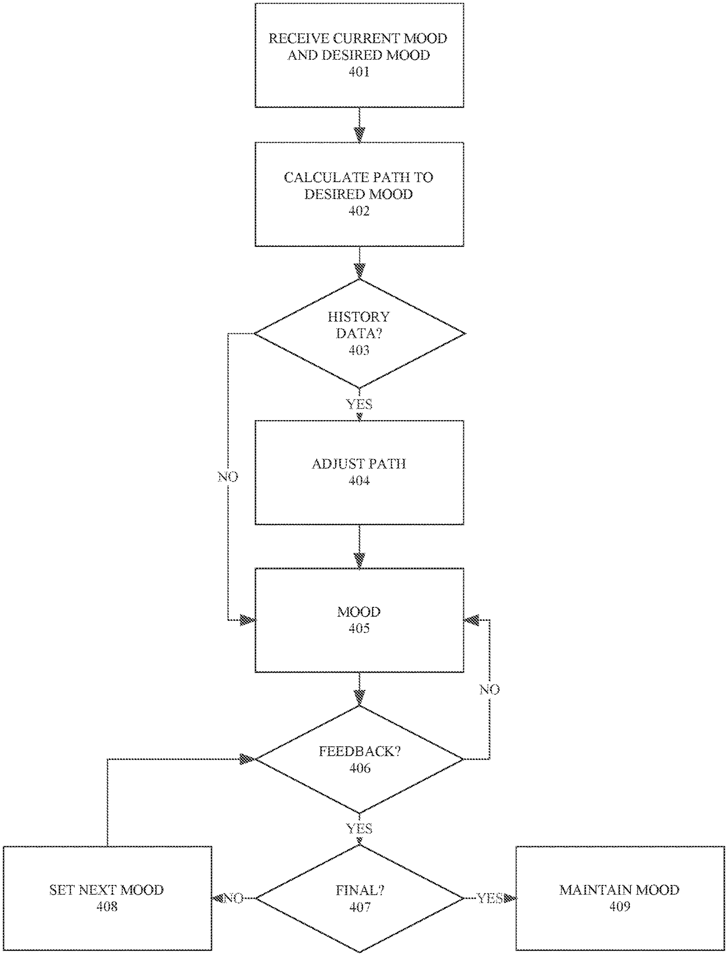
Figure 1. Gustman et al. (2021), Method and Apparatus for Mood Based Computing Experience, US20210011614A1

However, Daylio's implementation is limited to only being able to record a single dominant mood per entry, per day. Daylio also does not incorporate structured reflective prompts or integrated management tools. These limitations emphasize gaps in contemporary mood-tracking applications, especially in taking into consideration users’ emotional complexity and active regulation. In response to these limitations, Moodify is designed to take these gaps into account and extend beyond them. This is achieved by enabling multi-mood entries, structured reflective prompts, and integrated anxiety-management tools, therefore addressing the current limitations that modern mood-tracking applications have.

Catani et al. (2020), Systems and Methods for Wellness, Health, and Lifestyle Planning, Tracking, and Maintenance, US10614724B2
Catani et al developed a patented system, which allows individuals to plan, track, and manage their wellness, health, and lifestyle through personalized recommendation features on a single digital platform. Its key features are continuous monitoring of the individual's compliance, adaptive activity recommendations based on one's behavior and data. The primary beneficiaries of this are individuals who are seeking to improve their overall well-being. It provides activities and recommendations tailored to each individual and enables continuous monitoring of the individual. It helps individuals to improve or maintain their overall well-being by keeping track of their health and wellness through information and data-driven guidance. It is also useful in promoting healthier habits and in enhancing self-monitoring.
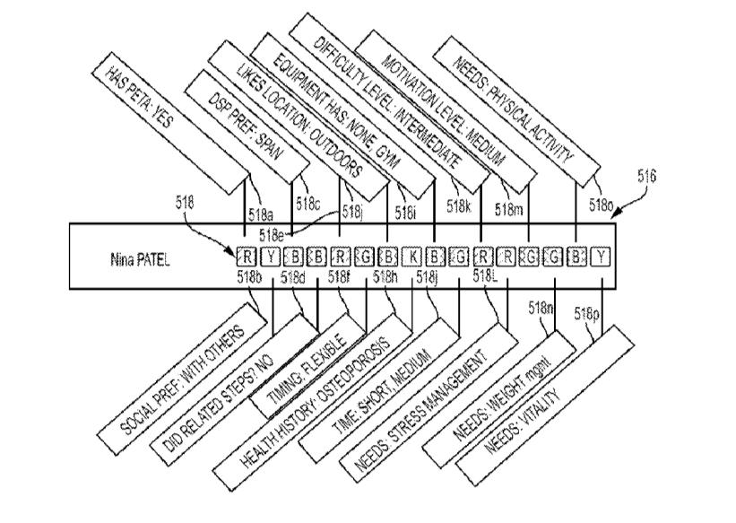
Figure 2. Catani et al. (2020), Systems and Methods for Wellness, Health, and Lifestyle Planning, Tracking, and Maintenance, US10614724B2

This patented system aligns with our capstone project, a mood tracker application, as it provides a strong foundation for understanding one's emotions and self-awareness. By emphasizing one's personalized tracking and user-specific recommendations, the patent basically supports our project’s goal, which is allowing users to record multiple moods throughout the day and examine the underlying factors which are affecting their emotional states. Our project is not focusing solely on one's emotions but also on what influences them or triggers them, thereby helping individuals to enhance their emotional awareness, emotional regulation and promoting intentional self-reflection.

Moskowitz (2021), Mood tracking and delivery of a therapeutic based on Emotional or Mental State of a User, US20210169389A1
Moskowitz (2021) created a system that provides a comprehensive method for assessing a user’s emotional or mental state and delivering personalized therapeutic content or interventions based on that assessment. This system combines mood tracking with the targeted delivery of both digital content and, potentially, dosage-dependent therapeutics (e.g., medication or other therapeutic agents) tailored to an individual’s specific emotional or mental condition. The system uses multiple sources of data, including text inputs, sensor data such as facial expressions or physiological signals, and dynamically generated mood maps to determine the user’s emotional state and provide appropriate digital messages or therapeutic support in response. Importantly, the system can personalise the content it delivers using an Emotional and Mental State (EMS) framework, which maps behavioural correlates such as positive/negative mood and active/passive engagement, enabling highly customised interventions. It also allows longitudinal tracking to monitor changes over time and adapt interventions accordingly.

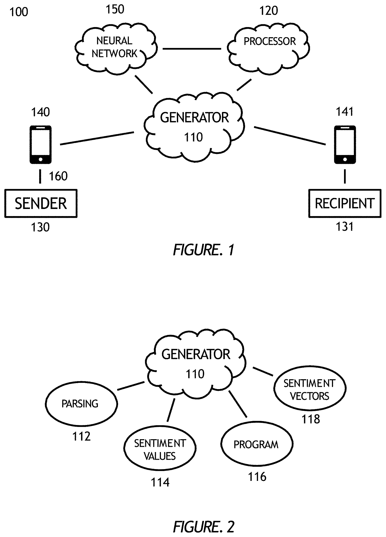
Figure 3. Moskowitz (2021), Mood tracking and delivery of a therapeutic based on Emotional or Mental State of a User, US20210169389A1

Additionally, this system emphasizes adaptive and preventive mental health support by enabling continuous feedback between the user and the platform. Through longitudinal data collection, the system can identify trends, early warning signs, and recurring emotional patterns, allowing interventions to be adjusted proactively rather than reactively. This capability supports sustained user engagement and long-term emotional regulation by refining therapeutic recommendations as the user’s emotional or mental state evolves. As a result, the system not only addresses immediate emotional needs but also contributes to ongoing mental wellness management, making it particularly relevant for personalized, technology-driven mental health intervention.

Cohen et al. (2023) System and Method for Monitoring Mental Health Conditions, US20230091240A1
Cohen et al. have developed a system that is patented and aims at monitoring a user’s mental state based on a combination of physiological information, social networking, and mobile device use behavior. The proposed system aims at detecting changes in a user’s emotional state related to mental well-being by concentrating on monitoring signs of stress, anxiety, and depression based on continuous monitoring of data inputs. The system has features that include an engine that can automate mental state classification and a real-time intervention module that uses the mental state classification and provides personalized “digital cues or therapeutic exercises.” The system also allows for longitudinal tracking to analyze emotional trends and incorporates a feedback mechanism which modifies the intervention program depending on the positive or negative response from the user. The combination of behavioral analytics and mobile technology enables the system to assist the user in recognizing the subconscious triggers and provides timely assistance in emergency emotional arousal states. The main target groups for the system include people who aim to improve emotional understanding and manage anxiety using data-informed support, as well as mental health practitioners who can apply the objective information from the system for patient tracking between sessions.
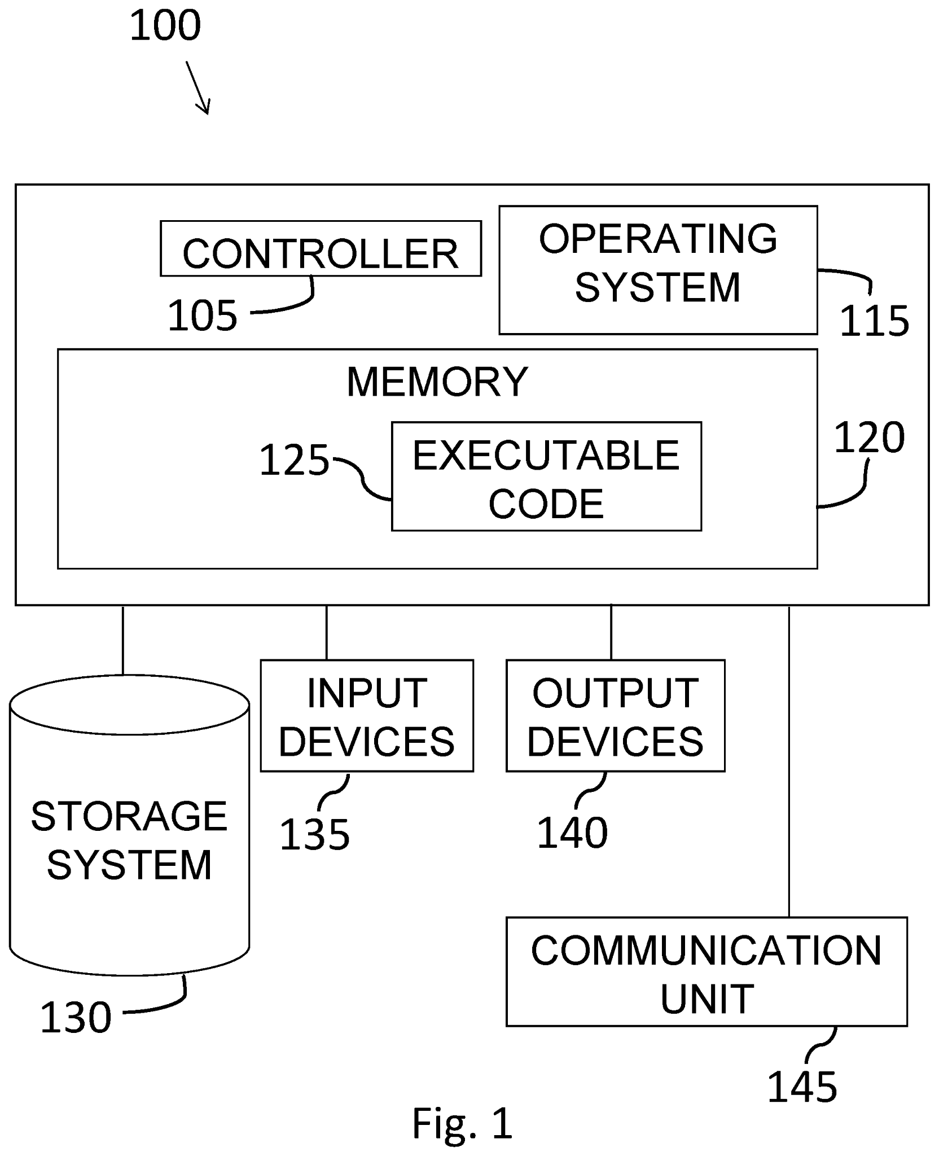
Figure 4. Cohen et al. (2023), System and Method for Monitoring Mental Health Conditions, US2023009124A1

The integration of the system framework from US2023009124A1 is directly related to the capstone project, Moodify, a.because it has the technological foundation for the app's "Anxiety Tools" module that delivers real-time interventions. Moreover, as part of the capstone objective to promote emotional awareness, this patent lays out a procedure for "Monitoring Mental State" that moves beyond recording by using behavior and biological patterns associated with anxiety even prior to its unconscious manifestation by the user himself. Thus, by harnessing this patented approach, Moodify has the ability to develop an automated feedback procedure that instantly distributes a series of direct therapy suggestions—like grounding procedures or cognitive tasks—the moment the subject's level of anxiety peaks. This integration is significant as it enables Moodify to function as a proactive mental support tool rather than a passive mood-logging application.

Scott, M. (2022) Application with mood recognition, tracking, and reactions, US20220012475A1
Existing mood-tracking technologies demonstrate how digital systems can monitor emotional changes throughout the day. Scott (2022) introduced a system that recognizes, tracks, and analyzes a user’s mood using both sensor input and manually entered data. The patent describes how the application observes emotional states, detects changes, and provides feedback or responses based on the user’s current mood. This development highlights how modern mood-tracking tools are progressing from simple emotion logging toward adaptive emotional interpretation, where understanding the cause and context behind a mood becomes increasingly important.
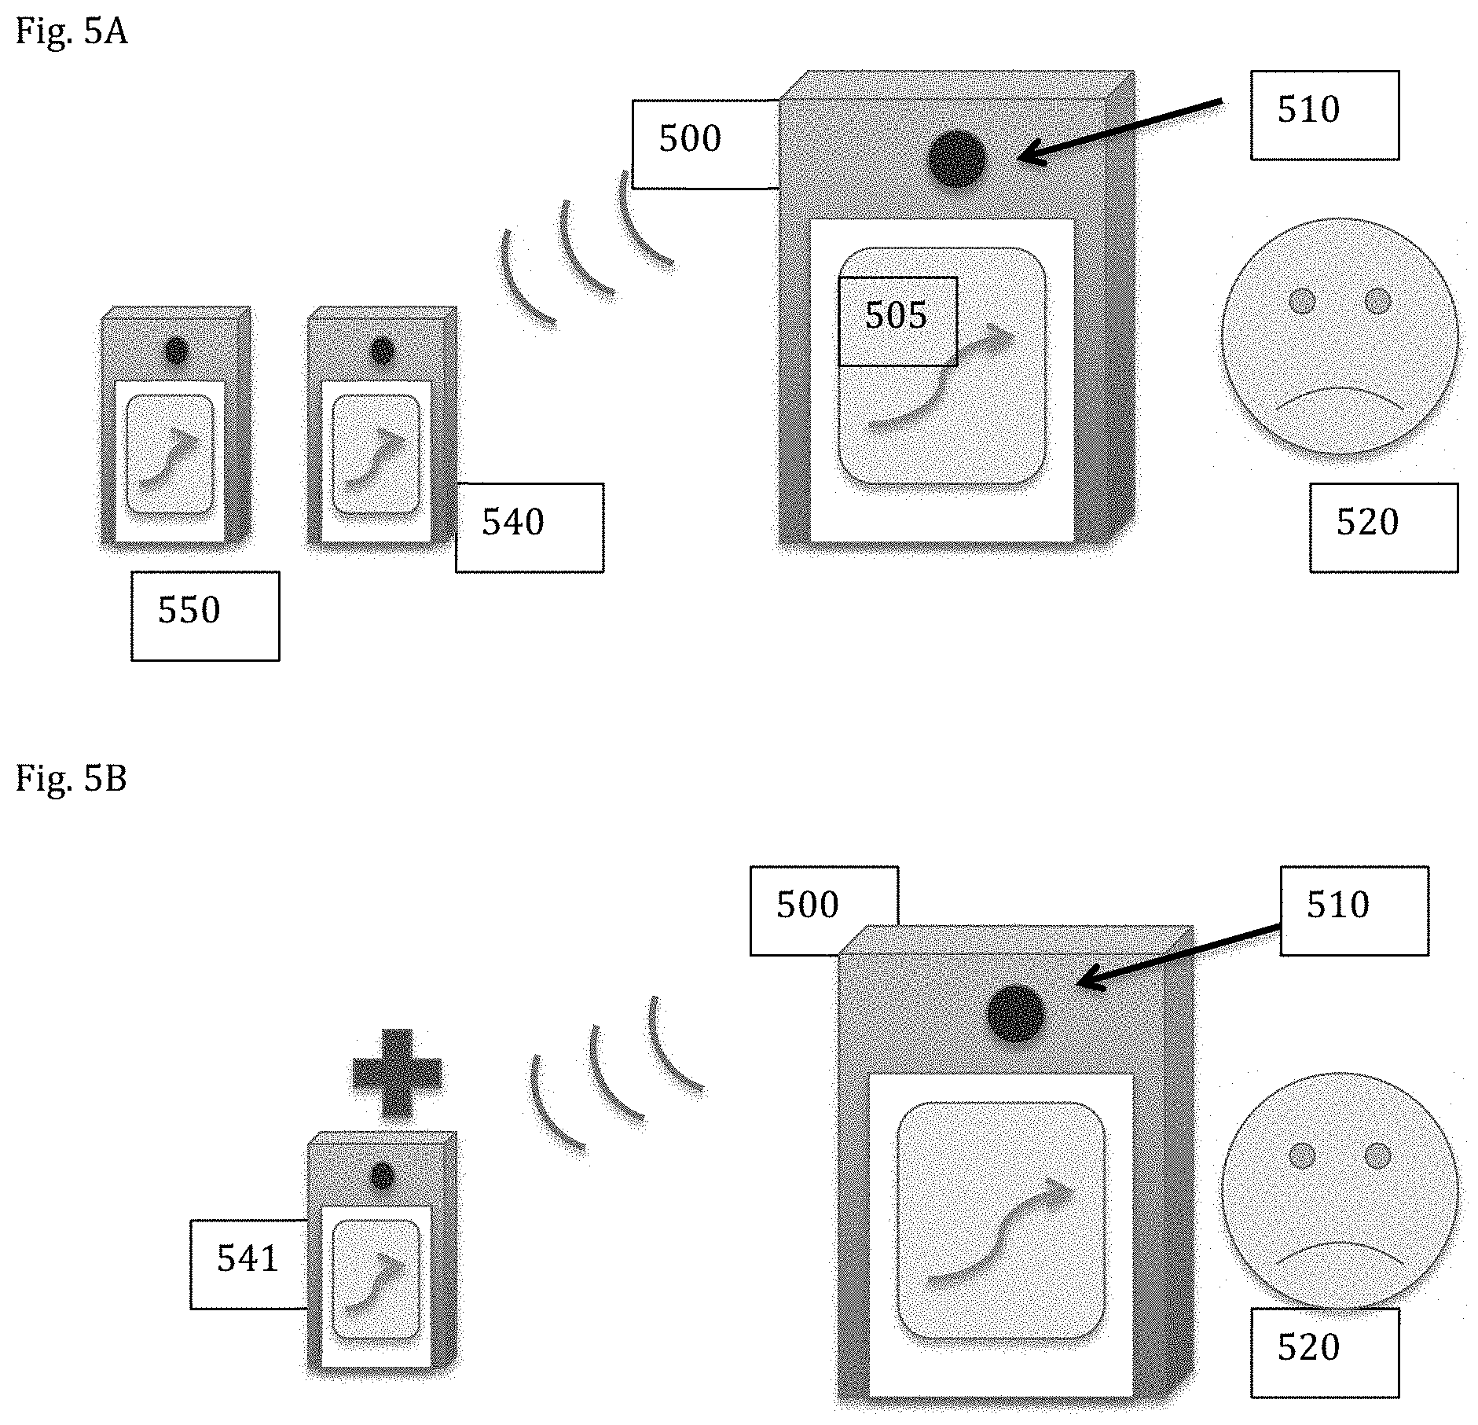
Figure 5. Scott, M. (2022) Application with mood recognition, tracking, and reactions, US20220012475A1

The proposed system is a mood-tracking application designed to record multiple emotions throughout the day while identifying the underlying causes behind each mood. Unlike typical mood trackers that only capture a single mood at a given time, this system allows users to input as many emotions as they want and answer guiding questions such as where they felt it, who influenced it, and what triggered it. Users may also write personal notes or reflections, similar to a digital diary, and mark their emotional state on a calendar using stickers or icons. Based on their entries, the app provides personalized suggestions such as breathing exercises, taking breaks, reading, or engaging in hobbies to help users regulate and improve their mood. The system does not just track emotions; it analyzes patterns, identifies sources, and offers evidence-based strategies to support the user’s emotional well-being.

Theoretical Framework
To properly guide this study and provide a solid foundation for the project, Appraisal Theory of Emotion (Anges Moors, 2017) and The 4R Model of Mood and Emotion for Sustainable Mental Health in Organisational Settings (Beedie et al., 2022) are introduced. These theories explore emotional variability, regulation, and awareness, which align with the study.

The 4R Model of Mood and Emotion for Sustainable Mental Health in Organisational Settings (Beedie et al., 2022). Most organizations recognise the importance of supporting one's mental health and emotional well-being. According to Beedie et al. (2022), the ability to manage and recognize one's mood plays a significant and important role in maintaining good performance and quality of life. This theory defines the difference between one's emotions and mood by looking at and comparing both cognitive thinking and biological processes. This is where they introduced the 4R model, which helps individuals recognize mood as distinct from an emotion or vice versa. It responds by recognizing, restoring, resolving, and regulating it. Mood can reflect the body's internal state, while emotions are the reactions to external events or happenings (Beedie et al., 2022). This approach is simple and can be applied in organisations without professional help.

This theory aligns with our capstone project, which is all about mood tracking, because it helps explain why emotional awareness differs among people, and it also highlights its importance, especially when it comes to self-awareness. According to Beedie et al. (2022), understanding one's emotions is a key socio-emotional skill that supports emotional regulation. In conclusion, the model aligns and supports our capstone projects by helping individuals understand better and manage their emotional state or experiences.

Appraisal Theory of Emotion (Agnes Moors, 2017). Appraisal Theory of Emotion (Agnes Moors, 2017) explains that emotions are not caused by the event itself, but rather by how individuals interpret (appraise) the event. According to Agnes Moors (2017), one event does not necessarily lead to one emotion, as it depends on the individual's appraisal, which is based on their goals, expectations, sense of control, and experience. These interpretations shape the intensity and type of emotional response. Given this, one individual may experience anger while someone with a different goal may experience indifference.

This theory aligns with our capstone project, which provides a strong foundation for understanding the variability in emotions and one's self-awareness. Moodify is designed to encourage users to write freely by not only recording their current mood but also the situation and how they interpreted it. This will help the users understand their response by recognizing the factors that affected their emotions. By identifying the patterns between the appraisal and the situation, users can easily identify the triggers that caused such emotions, possibly gaining the ability to manage their emotional state in the midst of the situation, and may develop healthier coping strategies, ultimately improving their emotional well-being.

Conceptual Framework
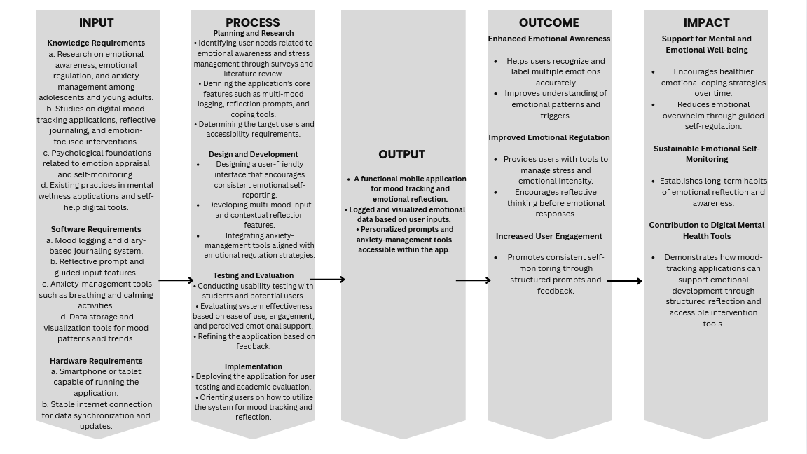
Figure 6. Input-Process-Output-Outcome-Impact (IPOOI) Conceptual Framework for Moodify: Mood Tracking App with Anxiety Tools for Emotional Awareness

The IPOOI framework guides the organized development of Moodify in order to properly convey how the Moodify application lifts emotional awareness and regulation. Inputs that heighten user experience and system effectiveness are also present, such as entries that don’t limit you to one mood entry, contextual reflections, and journaling-style notes are present and processed by the app’s system through data organization, pattern recognition and analysis, and personalized feedback generation. These outputs result in features such as mood visualizations, reflective insights, and emotional regulation tools. These features lead to outcomes like increased emotional awareness and improved recognition of emotional triggers over a short-term period. Over time, these results are projected to create positive impacts by further enhancing users’ emotional regulation and promoting healthier coping strategies among users.

Operational Definition of Terms
This section defines the key terms essential for understanding this study’s core concept. The key terms are operationally defined as follows:

Mood Tracking - This refers to recording and monitoring one's emotional state over time using an application. Users record their moods and emotional experiences daily in the mood tracking app to help identify patterns and use it as a diary.

Emotional Regulation - A technique or resource users use to manage their emotional responses. The mood tracking application will have a built-in tool, like breathing exercises and other tools that aim for emotional balance.

Emotional Awareness - The ability to identify and understand their feelings. Users use this to notice and label their mood, and also understand it through recording their mood regularly.

Self-reflection - The process of thoughtfully examining the user's mood and their emotional response. Users will review their records and reflect upon it through the mood tracking app to gain insights.

Triggers - This is an external or internal factor that is believed to be the cause of the user's mood. Identifying the factors will help develop a more accurate and effective self-regulation.

Chapter 2

METHODOLOGY

Research Design and Process Model
This study employs a quantitative descriptive and experimental research design. The experimental approach is used to examine users’ perceptions of the Moodify application as a tool for emotional awareness and emotional regulation by introducing the app as an intervention. As stated by Em (2024), experimental research is a scientific methodology used to determine cause‑and‑effect relationships by deliberately manipulating one or more independent variables and measuring the effects on dependent variables under controlled conditions. The "manipulation" of an independent variable is achieved by inserting Moodify as an intervention to observe its effects on users’ emotional awareness, regulation, and mood. The quantitative approach is appropriate for this study as it allows the researchers to collect measurable data regarding users’ experiences, system usability, and perceived effectiveness of the application’s features (Bhandari, 2020). A descriptive research design, as defined by Pubrica (2026), aims to systematically describe a population or phenomenon without influencing it without manipulation of variables. This is also utilized to capture and describe the current state of users’ interaction with the application without manipulating variables or introducing experimental conditions.

Data is gathered using a structured survey questionnaire administered to users after their time interacting with the application. The survey focuses on users’ general assessments of Moodify’s main features. Responses are analyzed using descriptive statistics such as frequency counts, mean scores, and standard deviation to summarize overall trends and patterns in user feedback. These statistical measures will be taken in order to provide clear bases for evaluating whether the application meets its intended objectives.
To assess the quality of the study’s developed system, chosen software quality indicators are used as criteria for evaluation. These indicators focus on how well the application performs its intended functions, how user-friendly it is, and how reliably it operates. The evaluation results serve as the basis for identifying areas for improvement and refinement.

Iteration 1: Core Mood Tracking and Reflection

Planning
The first phase focuses on defining the primary objective of the application and identifying its essential features. These include mood logging, reflective input, and basic emotional support tools. At this stage, user needs that are related to emotional awareness and stress management are considered.

Analysis
System requirements are examined to determine what the application must accomplish and how users are expected to interact with it. Attention is given to simplicity, accessibility, and clarity of emotional input mechanisms.

Design
The application’s layout and interaction flow are specifically designed to encourage consistent mood recording and reflection. Mood categories, prompts, and navigation structure are outlined to ensure ease of use.

Implementation
A working prototype of Moodify is developed, incorporating the planned features. This version allows users to log moods, respond to prompts, and view basic summaries of their emotional data.

Testing
The prototype undergoes initial testing to identify functional errors and usability issues. User interaction with the system is observed to determine whether features operate as intended.

Evaluation
User feedback and survey responses are reviewed to assess the system’s effectiveness and usability. The results of this evaluation indicate whether the application meets its design goals.
Refinement
Based on the evaluation findings, adjustments are made to improve feature clarity, interface design, and overall user experience. These refinements prepare the system for further iterations.
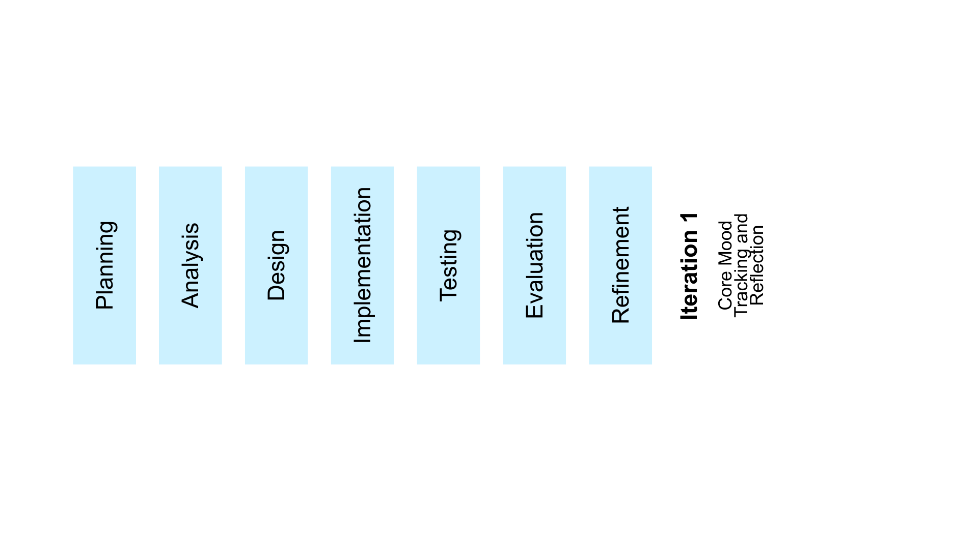
Figure 7. Iteration Model for Moodify: A Mood Tracking Application with Regulation Tools for Emotional Awareness

Locale
The study will be conducted at 7.06309, 125.59580 Mapua Malayan Colleges Mindanao (MMCM) in Davao City, Davao Del Sur. The institution provides a safe and organized environment equipped with technologies and facilities that are needed for developing, especially for testing the Moodify application. Students in MMCM have access to their internet and computers that will greatly help in checking and ensuring the development of the Moodify application. The study is going to be done in MMCM since the students here are going to be the main users of the application, and mainly because taking care of student's mental health can greatly help them, especially in doing tasks effectively and efficiently. The study will mainly focus on the students' emotional awareness and emotional regulation tools.

Research Participants
The testers were selected through a purposive sampling method to ensure all the respondents have relevant experience and knowledge to aid with the development of the application (Tajik et al., 2024). The study involved two groups of participants: the end users consisted of students from MMCM, regardless of age, to evaluate how well Moodify enables emotional awareness. The expert evaluators included IT professionals and therapists for reliable evaluation and feedback for the prototype. The sample size would be a minimum of 5 and a total of 30 respondents. For experts, 3 to 5 respondents per group is sufficient for identifying any issues and concerns towards the application, as their evaluation focuses on the quality and depth of feedback rather than quantity. For students, end users of the application, the sample size was based on the standards of usability testing, ranging from 15 to 30 respondents (Strba, 2024). This study will make use of 20 students to provide their overall user experience and feedback on the application.

The end user participants are selected through the following criteria:
A. Must be a student in MMCM
B. Must have any experience using mobile phones or smartphones
C. Voluntarily participated in the research capstone project.

The expert evaluators are selected through the following criteria:
A. Must be at least 18 years of age
B. Must have any experience using mobile phones or smartphones
C. Must possess expertise in application development and mental health
D. Voluntarily participated in the research capstone project.

Personal Data | Category | The Number | Percentage Distribution %
Web Developer | IT Experts | 5 | 16.67%
Therapists | Mental Health Prof. | 5 | 16.67%
MMCM | Students | 20 | 66.67%

Table 1. Number of Respondents

Research Assessment Tool
The primary research assessment tool used in this study is a structured survey questionnaire designed to evaluate Moodify. The questionnaire was developed to align with research objective 2, which examines Moodify’s performance in terms of (a) Functionality, (b) Usability, (c) Reliability, (d) Performance, and (e) Supportability.
For objective 3, the developers adapted and adjusted a reliable and validated instrument by Arifin & Maharani (2021), “Assessing User Experience of a Mobile Application Using Usability Questionnaire Method” to be based on the users’ satisfaction after using Moodify for three (3) weeks, making this questionnaire align with the third objective. The questionnaire is divided into two parts. Part I gathers the respondents’ characteristics. Part II consists of 25 evaluative statements divided into 4 sections: Usefulness, Satisfaction, Ease of Use, and Ease of Learning. This instrument uses a five-point Likert scale corresponding to Strongly Agree, Agree, Doubt, Disagree, Strongly Disagree.
These questionnaires ensure a credible and comprehensive evaluation that identifies the strengths and weaknesses that could be further improved.
The descriptive statistics was employed for the data analysis, specifically measuring the mean. Shown in Table 2 is the mean interpretation table for evaluating the prototype’s performance based on FURPS criteria, while Table 3 is the mean interpretation table for evaluating the user experience of the participants. Analyzing the collected data was made possible due to these tables, providing a better understanding of the project’s outcomes. These tables serve as a structured framework for analyzing collected data to give a better understanding of the project.

Rating Scale | Verbal Description | Interpretation
 |  | Functionality | Usability | Reliability | Performance | Supportability
4.21 - 5.00 | Very Good | App works as intended and effectively supports the available features. | Easy to use and navigate. | Consistently with minimal errors. | Exceptional speed and response. | Easily maintainable and provides sufficient guidance to users.
3.41 - 4.20 | Good | Most features operate as intended with minor areas for improvement. | Generally usable with occasional difficulty. | Mostly reliable with occasional issues. | Performs above-average with slight delays. | Provides basic support but may need improvements.
2.26 - 3.40 | Acceptable | Core features operate as intended but need noticeable improvements. | Usable but may cause confusion. | Operates with occasional errors. | Performance may experience occasional delays. | Support and maintenance features are limited.
1.81 - 2.60 | Poor | Many features do not operate as intended. | Difficult to use and understand. | Frequent errors influence user experience. | Performance is slow and inefficient. | Lacks adequate support or maintainability.
1.00 - 1.80 | Very Poor | Essential features fail to operate as intended. | Extremely confusing and difficult to use. | Unreliable with frequent failures. | Performance is extremely poor with long delays. | Provides little to no support and maintenance.
Table 2. Mean Interpretation of the FURPS Criteria

Rating Scale | Verbal Description | Interpretation
 |  | Usefulness | Ease of Use | Ease of Learning | Satisfaction
4.21 - 5.00 | Strongly Agree | The application is highly useful in helping users track and understand their moods. | Extremely easy to use and navigate. | Users’ learn how to to use the application very quickly. | Highly satisfied with the application.
3.42 - 4.20 | Agree | The application is useful in helping users track their moods. | Easy to use with minimal difficulty. | Users’ learn how to use the application with minimal effort | Satisfied with the overall experience of the application.
2.61 - 3.40 | Doubt | Somewhat useful with minor areas for improvements. | Somewhat easy to use but with minor confusion. | Users may require guidance to learn how to use the application | Neutral about the overall experience with the application
1.81 – 2.60 | Disagree | The application has limited usefulness in tracking moods. | Difficult to use and navigate. | Users struggles in learning how to use the application. | Not satisfied with the application
1.00 – 1.80 | Strongly Disagree | The application is not useful in helping users track their moods. | Extremely difficult to use and navigate. | Users cannot easily learn how to use the application. | Very dissatisfied with he overall experience of the application.
Table 3. Mean Interpretation of User Experience

System Development Tools
This project developed a user-friendly and robust mood-tracking mobile application, entitled Moodify, by integrating essential software development tools and technologies. These tools supported the design and implementation of the system for its usability and functionality. The particular tools used include Flutter, the primary development framework, which allowed for efficient creation of a responsive mobile application. Firebase supported this through cloud-based backend services for data storage and user authentication. Moreover, intuitive user interfaces were designed using Figma, while Git and GitHub allowed for version control and collaborative development. The system was further tested and debugged for stability in Android Studio. The summary of the development tools used in developing the system, including a description of their functions in the development of Moodify, is found in Table 4.

Development Tools | Description | Function
Software:
Flutter | Flutter is an open-source, cross-platform mobile application development framework developed by Google. It allows developers to build applications using a single codebase while maintaining native performance and responsive interfaces. | Used as the primary framework for developing the Moodify mobile application, including mood logging, reflective prompts, and navigation features.
Firebase | Firebase is a cloud-based backend platform that provides real-time database services, cloud storage, and application hosting. | Used to store user mood logs, reflection responses, and application data securely while enabling real-time synchronization.
Firebase Authentication | Firebase Authentication is a service that provides secure user authentication using email and password credentials. | Used to manage user registration, login, and secure access to individual user data.
Figma | Figma is a collaborative user interface (UI) and user experience (UX) design and prototyping tool used to create wireframes and interface layouts. | Used to design the user interface of Moodify, including mood selection screens and reflection prompts, prior to development.
Git | Git is a distributed version control system that tracks changes in source code during development. | Used to manage code versions and track changes throughout the system development process.
GitHub | GitHub is a web-based repository hosting service that supports collaboration using Git. | Used as the central repository for storing project source code and enabling collaboration among developers.
IbisPaint X | Ibispaint is a mobile drawing application | Used to create assets such as icons, logos, & images
Android Studio | Android Studio is an integrated development environment (IDE) for developing Android applications, providing emulators and debugging tools. | Used for testing, debugging, and evaluating the performance and functionality of the Moodify application.
Hardware:
Laptop/Computer | The laptop/computer was used for software development, coding, as well as project management. | The computer played a key role in allowing the developers to develop, design, test, and manage the application using the tools of Android Studio, Figma, and GitHub

Table 4. Moodify System Development Tool

Flutter
Flutter was an important aspect in the development of the Moodify application, as it acted as the core framework for building the mobile application. Its ability to support multiple platforms made it possible for the developers to include core functionalities such as mood logging, reflection, and monitoring of emotions in one application. Responsiveness was another aspect of the framework that made user experience smooth.

Firebase
Firebase served as the backend support for the system. It provided real-time database capabilities and secure cloud storage. It enabled the system to efficiently store the mood entries and responses to reflection questions of the users while maintaining data synchronization and availability. Firebase's scalability and reliability facilitated the sustained usage of the application.

Firebase Authentication
Firebase Authentication was incorporated into the system to provide a safe way for users to access it. This application enabled users to register and log into their accounts safely, and their moods would only be accessible to users with authorization.

Figma
Figma was used in the designing phase of the project for wireframing and interfacing the prototype. Its collaboration features allowed developers to design user-friendly layouts for mood logging and reflection features, ensuring that the application followed user-centered design principles.

Git and GitHub
The source code was managed along with the development versions using Git and GitHub. In this way, the developers used these tools to track changes, maintain neat and clean code, and enable coordination throughout the development process to avoid incidences of errors for better system reliability.
IbisPaint X
IbisPaint X was mainly used for design. It is used to create assets such as icons, logos, images, and other elements which makes Moodify more visually appealing to the users.

Android Studio
The environment used for testing and debugging the application was Android Studio. Through emulators and testing on an actual device, the developers were able to assess the performance of the system, find bugs, and ensure that Moodify runs smoothly and functions properly on Android devices.

Laptop
The laptop/computer was used for software development, coding, as well as project management. The computer played a key role in allowing the developers to develop, design, test, and manage the application using the tools of Android Studio, Figma, and GitHub

Data Gathering Procedures

Before Collection
In developing the application, the developers reviewed studies and theories regarding mood, emotion, and emotional regulation, incorporating a variety of mood options and enhancing the emotional regulation suggestions in terms of accuracy and relevance. Before collecting the data, the developers consulted Information technology (IT) professionals to ensure the app's architecture and data handling were ethical and proper. With the professional's help, the developers were able to develop and design the mood tracking application and conducted a beta test to identify any errors and bugs. Following ethical conduct, respondents, especially minors, are given informed consent that explains the purpose of the app and whether they are willing to participate in this project. Since the study is conducted in school, the developers will submit a letter of approval to the school principal and advisors to obtain permission to conduct this project within the school grounds.

During Collection
During data collection, the developers will gather respondents who meet the study criteria along with IT professionals. Afterwards, the participants will be provided access to the application through a downloadable APK file. To avoid any complications with the app, the developers will guide the participants on how to use the application and record their daily mood entries. Then, the participants will use the application for a specific period of 3 weeks. The developers will then use Microsoft Forms and forward the questionnaire to the respondents through email at a specific time and date to evaluate user experience and outcomes. Afterwards, the collected data were handled securely, maintaining confidentiality and ethical compliance.

After Collection
After collecting the data, it is first reviewed by the IT professionals and validated by the school administrators before the developers analyze it to evaluate the application's effectiveness, usability, impact on the user, and identify any areas that need improvement. Afterwards is the stage of interpretation—crucial to determine the needs of the application. This acts as the final test before the application is presented to the public. In this managed environment, the main focus is to detect and fix as many bugs and issues that could hinder the usability of Moodify, based on the data gathered. The developers used a research descriptive design to evaluate the overall data of the user’s experiences and carefully examined it to ensure the success of Moodify’s purpose.

Trustworthiness of the Study

The researchers considered it essential that the data collected for the study was absolute, dependable, and bona fide. To measure the reliability of the study, the developers resorted to the concepts of credibility, transferability, confirmability, and dependability. The next section will elaborate on this topic to indicate the extent to which the users can rely on the data.

Credibility. To ensure the credibility of the study, systematic and rigorous measures were implemented throughout the development and evaluation phases. A quantitative research approach was employed, focusing on numerical data analysis to objectively evaluate the system’s performance. A structured research questionnaire based on established software quality indicators was used to assess the Moodify prototype. Moreover, the research took on an Incremental Development Model, which permitted the system to go through several development cycles comprising analysis, design, implementation, and testing. This iterative process ensured continuous improvement of system features. Member-checking techniques were also applied to validate the accuracy of user feedback and confirm the relevance of the collected data.

Transferability. The transferability of the study was strengthened through the use of an online research questionnaire designed for replication in similar studies. The indicators and evaluation methods were structured to be flexible and applicable across different user groups and settings. Additionally, the research procedure, that is, the way the developers selected the respondents, the methods of data collection, and the techniques for analyzing the data, was made very clear and detailed. In this way, these metrics not only render the findings useful beyond the original context but also allow other researchers to tailor the study's methodology to systems or situations similar to the original one.

Confirmability. The system was evaluated using a carefully crafted research assessment tool that was developed from published studies and in line with accepted software quality standards like ISO/IEC 25010 in order to guarantee confirmability. In addition to ensuring that conclusions were drawn directly from the data gathered, this uniform evaluation methodology reduced researcher bias. Documented system testing and user evaluation results bolstered the study's neutrality and verifiability.

Dependability. Dependability was attained by applying research and development methods consistently and thoroughly documented. To detect and minimize any biases, every phase of the system development process—analysis, planning, implementation, and testing—was meticulously carried out and examined. The consistency and dependability of the data gathered were further guaranteed by the application of a precisely defined rating scale, consistent data collection techniques, and adherence to ethical issues. These procedures show that the study's conclusions are reliable and repeatable under comparable circumstances.

Ethical Considerations

As this study involves the collection of user data, it is essential to follow the ethical guidelines for the development of Moodify to ensure the protection and fairness of every respondent. This section discusses the ethical considerations observed in conducting this study.

Transparency. All individuals involved in the study, including users, teachers, and specialists, will be clearly informed about the purpose, methods, and possible outcomes of the research. The way mood data is gathered, analyzed, and used to generate suggestions will be explained in simple and understandable terms. Participants will be given detailed consent forms before taking part, making it clear that their involvement is completely voluntary and that they can withdraw at any time without penalty. Regular briefings and informational sessions will be conducted to keep participants well-informed throughout the study.

Justice. The study promotes fairness by ensuring that all participants have equal opportunities to take part and benefit from the research, regardless of their background. Every contribution, whether emotional input, feedback, or suggestions, will be valued and accurately represented. Participants will be actively involved in improving the app through surveys, feedback, and discussions, helping to ensure that it truly meets users’ needs and supports overall well-being.

Informed Consent. Before participating, all individuals will receive clear and complete information about the nature and goals of the research. Consent will be given freely, without any form of pressure or coercion, and participants may choose to leave the study at any time. They will be fully informed about what kind of mood-related data they are sharing, how it will be used, and how their privacy will be protected. Written consent forms will outline all procedures, confidentiality measures, and participant rights before any data collection begins.

Privacy and Confidentiality. All personal data, including mood logs, journal entries, and calendar notes, will be securely stored with access limited to authorized personnel only. Any information used in research reports will be anonymized to prevent identification of participants. No personal data will be shared outside the approved research setting. These safeguards allow users to express and record their emotions freely, knowing their privacy is protected.

Social Value. The project aims to create a positive social impact by encouraging emotional awareness, healthy coping strategies, and mental well-being. Through personalized suggestions such as breathing exercises, journaling, or taking breaks, the app helps users better understand and manage their emotions. The research is designed to benefit students, educators, and individuals seeking emotional support. Potential risks will be carefully assessed, and the system will be continuously improved to ensure a safe and supportive experience.

Risk, Benefits, and Safety. Although reflecting on emotions may sometimes cause mild discomfort, the app reduces risks by offering gentle and supportive coping strategies. Participants will be clearly informed that the app is not a replacement for professional mental health care, and guidance will be provided on how to seek help when needed. The benefits of increased self-awareness, emotional reflection, and healthier coping habits are highlighted to ensure that participation is meaningful and beneficial.

Qualifications of Developers and Researchers. The development team includes professionals with experience in app development, data security, and fundamental psychology. Additionally, expert consultants are involved to ensure that all app recommendations are safe, scientifically supported, and appropriate for users.

Adequacy of Facilities and Resources. The project uses secure digital systems, encrypted servers, and protected databases for data storage and analysis. Users will also have access to support materials such as tutorials, FAQs, and direct contact options to help them use the app effectively and address any concerns.

Community Involvement. Users, educators, and other stakeholders will play an active role in designing, testing, and evaluating the app through surveys and feedback sessions. Their participation ensures that the app truly reflects user needs and builds trust and collaboration. This shared involvement strengthens the ethical foundation of the project and makes the research more meaningful and socially relevant.
Chapter 3

PROJECT DESIGN

In this section of the project, a comprehensive overview of the development and creation of Moodify is presented. It involves discussing certain key elements, such as the project model, project mechanism, source code, project manual, and project cost. Each element will be thoroughly explained to provide a deep understanding of the process and act as a guide for developers in developing the project. This section aims to provide an in-depth explanation of the project's process, execution, and maintenance to allow a more comprehensive understanding of the developmental process as a whole.

Project Model
The project model focuses on the key components that build the overall structure and workflow of Moodify. Outlining the application's functions helps clarify how Moodify operates as a unified system and serves as a guide for the development and evaluation. Figure 8 presents the application logo along with the home interface of the application. The logo represents Moodify's identity and purpose, which also serves as the user's first look, while the home interface serves as a welcome and entry point for all users before accessing the core features. Presenting these elements is essential, as it provides the user with an immediate visual understanding of how the design and functionality of Moodify is intended.
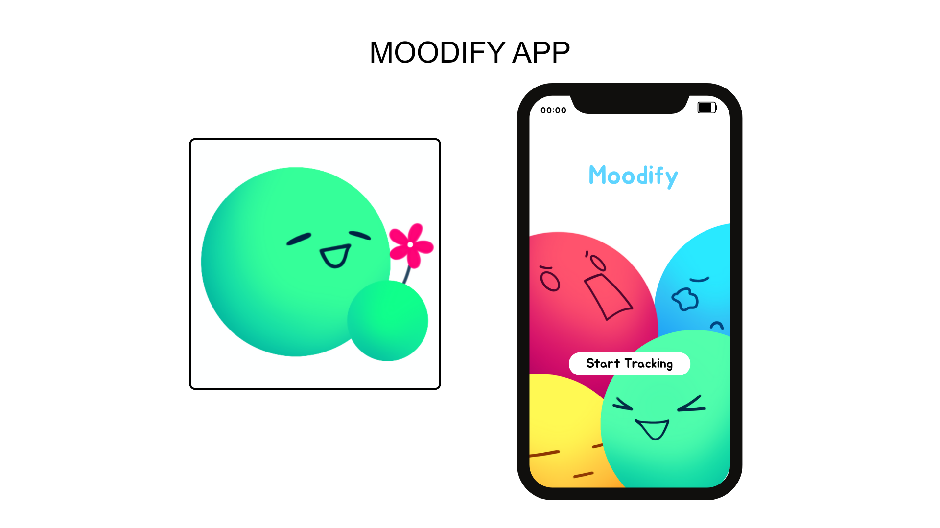
Figure 8. Model of Moodify
Moodify App Blueprint

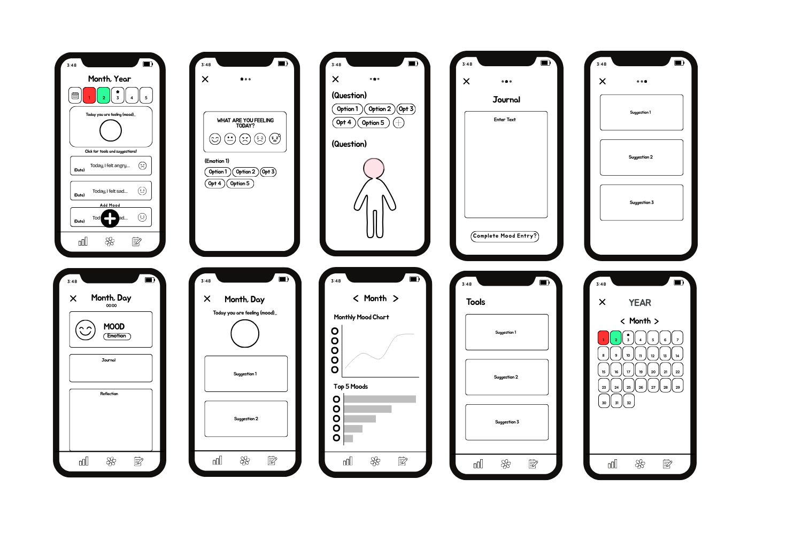
Figure 9. Blueprint of Moodify App

Shown if Figure 9 is the blueprint of Moodify that showcases the features and services the application offers. It includes the home page, mood & emotion selection, self-reflection section, journal section, mood charts, mood entry review, and tools & suggestions for emotional regulation.

Moodify Mobile Application Details
- Home interface
The home interface of Moodify welcomes the users to the app. It is designed to have a simple yet soothing minimalist design, featuring a layout with a start button. This design allows the users to navigate through the app with ease, making it accessible to all.
- Home Page
The Home Page will serve as the main interface of the application. This is where users can start tracking their mood by pressing the plus (+) button on the bottom of the screen, in which you can also see the home bottom, mood charts button, and regulation tools button. In addition, It features a calendar view that allows users to review their recorded moods and emotional entries on a daily basis.
- Mood and Emotion Selection
Upon selecting the tracking option, users are prompted to choose their current mood and emotion from a set of predefined options that best represent their emotional state. This feature will assist users in accurately identifying their mood and labeling their emotions.
- Self-reflection Section
The self-reflection questions section are a set of questions the users answer after choosing their mood. This section was designed to encourage the users to have deeper emotional awareness by guiding them to reflect on their emotional experience. This section includes self-reflection prompts that will help the users to identify or record what triggered their mood, how they responded to it, whether their responses were right or wrong, and in what part of the body they feel such mood or emotion. Users may select from predefined options or add their own choices when none of the options best represent their experience.
- Journal Section
The Notes or Diary section is where users can document their experiences, reflections, thoughts, and happenings in their lives that are related to their emotional state. It provides users private space and this feature also encourages them to express their thoughts, which will help and support their emotions through writing their hearts out.
- Mood Charts
The mood chart section provides a visual data representation of the user’s recorded mood over a month and also showing the frequency of each mood. This feature could help users identify emotional patterns over time.
- Mood Entry Review
This section is a feature where users can look back at their previous entries, allowing them to analyze and reflect on their past experiences. It includes the user’s answers to the questions they were asked along with the journal entry of that day.
- Overall Mood of the Day
The overall mood of the day can be seen in the home page. It shows the overall mood of the user based on the mood entries that was recorded within the day. Based on the overall mood, the system will provide a personalized emotional regulation suggestion.
- Monthly Calendar
This monthly calendar feature provides the users a visual representation of their mood history where each day is color-coded based on their overall mood for that specific day, allowing them to not only easily navigate by selecting a specific month, year, or day to view the mood entry they recorded but also to recognize potential patterns.
- Tools and Suggestions for Emotional Regulation
The application will provide personalized suggestions and some coping strategies that will be helpful based on the user’s selected mood and emotion. These may include breathing exercises, self-care activities, relaxation techniques, and positive affirmations solely designed to help users regulate their emotions effectively.

Product Details

Application Title
Moodify is a name formed from the words “mood” and “identify.” It represents the core idea of the application, which is helping users become more aware of what they are feeling. Emotions are often complex and hard to understand, and many people experience different moods throughout the day without fully recognizing them. The name Moodify reflects the goal of turning these emotions into something identifiable and understandable. The application relates to its name by allowing users to track and identify their moods regularly. Through simple mood logging, users can record how they feel at different moments, making it easier to notice emotional changes that might otherwise go unnoticed. By identifying their moods, users gain a clearer picture of their emotional state rather than ignoring or suppressing what they feel.

In addition, Moodify encourages reflection. The app gives users the opportunity to think about what caused their emotions, such as daily events, interactions, or personal experiences. This reflective process helps users understand why they feel a certain way and recognize recurring mood patterns over time, which is an important step toward emotional awareness. Ultimately, Moodify is not just about tracking emotions but also about learning how to manage them. By helping users identify their moods, reflect on them, and observe patterns, the application supports better emotional regulation. In this way, the name Moodify perfectly represents the purpose of the app to help users understand their emotions and take meaningful steps toward improving their emotional well being.

Moodify Mobile Application Flowchart
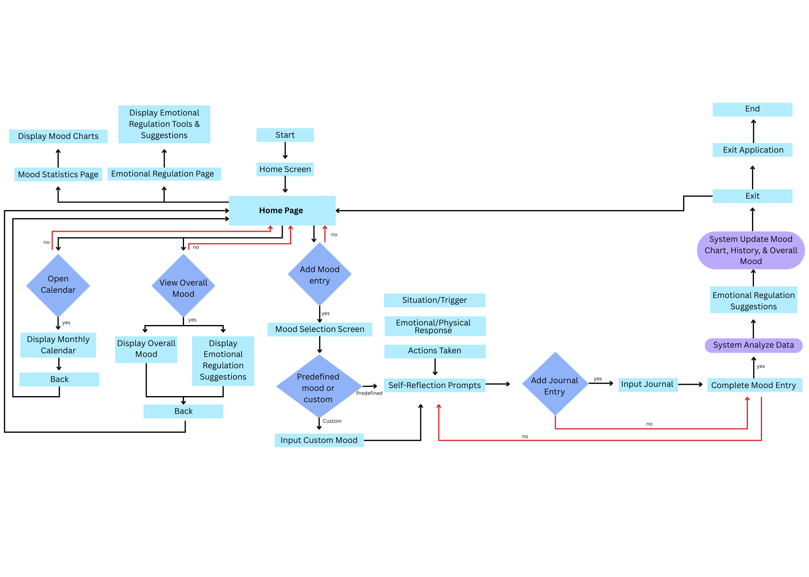
Figure 10. Moodify Mobile Application Flowchart

Figure 10 shows the workflow of Moodify, starting from the initial access to suggestions for emotional regulation. It highlights the overall process, outlining the key stages mainly mood selection, reflection prompts, data visualization, and emotional regulation tools & suggestions, ensuring a smooth user experience. Decision points were also added within the flow to ensure accurate and complete entries. Additionally, the repeating cycle of mood entries, reviewing emotional tendencies, and acquiring emotional regulation suggestions enables the users to gain deeper insights overtime. Ultimately, the flow chart is a clear demonstration of how a well-structured application process guides users toward long-term emotional monitoring and understanding.

System Architechture Diagram
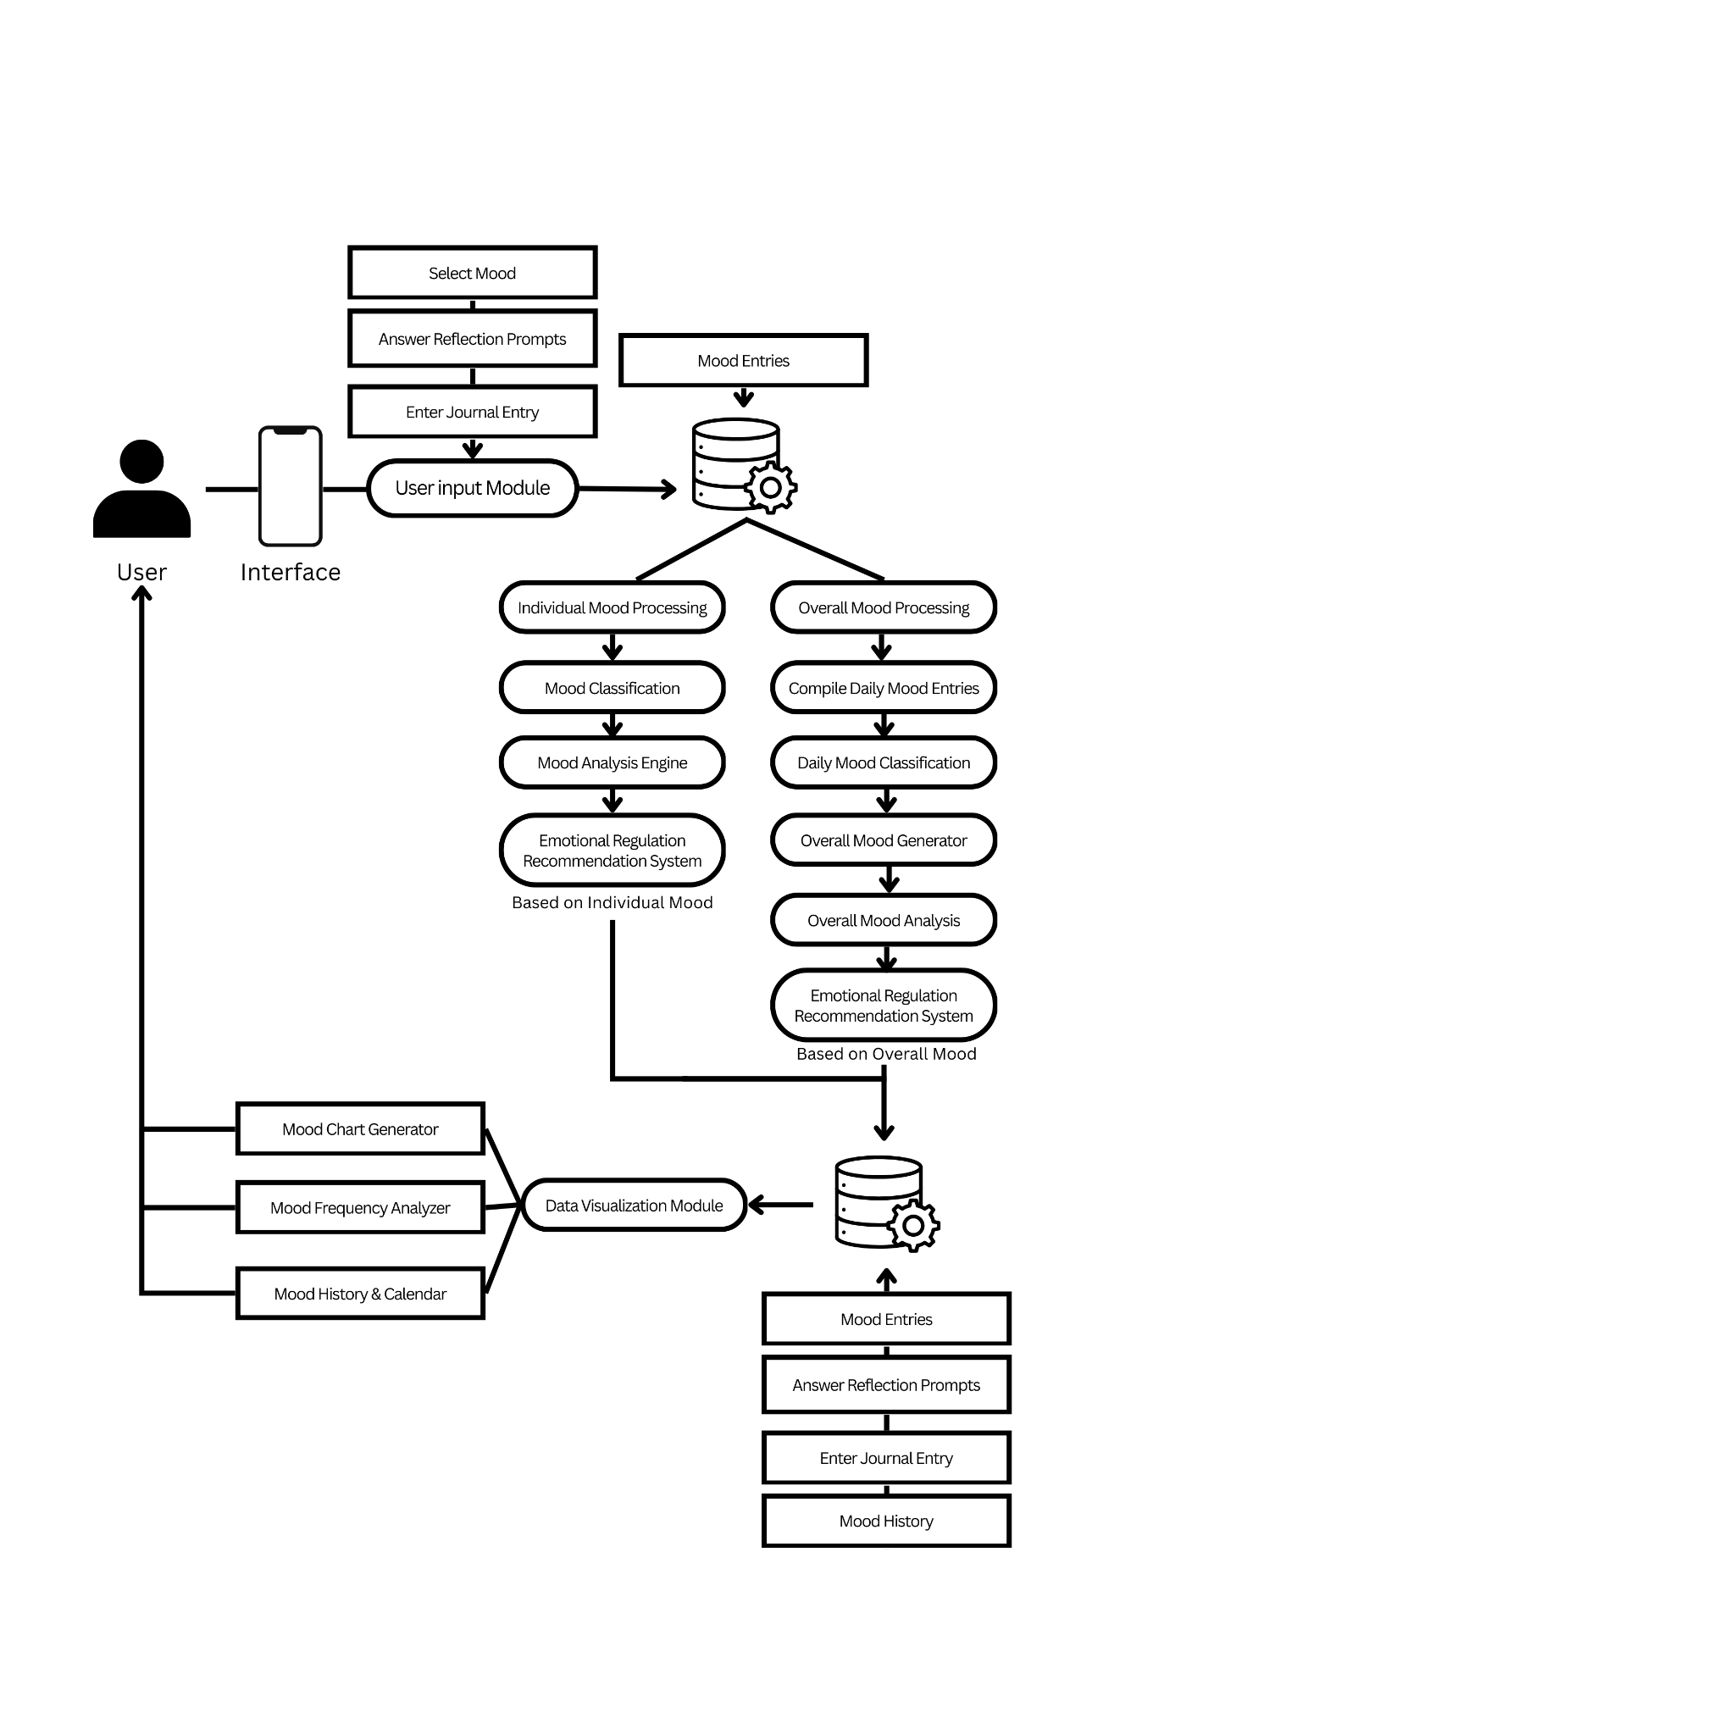
Figure 11. System Architecture Diagram of Moodify

The process begins when the user interacts with the application interface by selecting their mood, answering reflection prompts, and entering a journal entry. These inputs are collected through the User Input Module and stored in the database as mood entries.
After the data is stored, the system processes the information in two ways: individual mood processing and overall mood processing. In individual mood processing, the system classifies the user’s current mood and analyzes it using the Mood Analysis Engine. Based on the results, the system provides emotional regulation recommendations tailored to the user’s current emotional state.
At the same time, the system performs overall mood processing, where it compiles daily mood entries and classifies them to generate an overall mood summary. This summary is then analyzed to provide emotional regulation recommendations based on the user’s overall mood trends.
Finally, the processed data is sent to the Data Visualization Module, which generates features such as a mood chart generator, mood frequency analyzer, and mood history and calendar. These visualizations allow the user to track and understand their mood patterns over time.

Application requirements
- User Requirements
Users must be able to view stored information in an organized and easy-to-understand manner through a clear and intuitive interface, add, edit, update, and delete stored information within the system, search or filter data for faster access, receive notifications or reminders from the system and customize these according to their preferences, access help or support features including basic instructions or tutorials, view and update their profile information, manage privacy and security settings, expect that all personal data stored within the application is kept private and secure at all times, and ensure that saved data is retained and not lost when the application is closed or exited.

- Software Requirements
To ensure stable and efficient performance, the application requires a device that meets specific hardware requirements. At a minimum, the application needs a 1.6 GHz dual-core processor and 2 GB of RAM to allow users to navigate the app, record mood entries, and access essential features smoothly. For enhanced performance with faster loading times and improved responsiveness, a device with a 2.0 GHz quad-core processor and at least 4 GB of RAM is recommended. The device should also have sufficient battery capacity to support a minimum of 30 minutes of active use, while a longer battery duration of 60 minutes or more is preferred for extended sessions.
The application can be effectively operated in any type of device, either IOS or Android. The application is designed to run on devices using the Android operating system, with Android 8.0 (Oreo) as the minimum requirement to support core functions such as data storage, mood visualization, and user interaction. For enhanced security, better performance, and compatibility with future updates, Android 11 or later is recommended. Adequate storage capacity is also required, with at least 100 MB of free space needed for installation and basic data storage, while 300 MB or more is recommended to store mood records, journal entries, and future updates. Additionally, the application requires a minimum screen resolution of 1280 x 720 (HD) to ensure clear text and readable charts, while resolution of 1920 x 1080 (Full HD) or higher is recommended for improved visual clarity. These system requirements ensure the stability, accessibility, and overall effectiveness of the Moodify Mobile Application.

Complete Specifications

Moodify highly encourages a device that meets specific hardware and software specification to ensure an optimal user experience. Table 5 outlines the minimum and recommended system requirements for the application to operate smoothly.

Requirement Category | Specs | Minimum Specifications | Recommended Specifications
User (Hardware) | Processor (CPU) | 1.6 GHz dual-core processor | 2.0 GHz quad-core processor or higher
 | Memory (RAM) | 2 GB | 4 GB or more
 | Battery Capacity | Supports at least 30 minutes of active use | Supports 60 minutes or more of active use
Software (System) | Operating System | Android 8.0 (Oreo) | Android 11 or later
 | Storage Capacity | 100 MB free space | 300 MB or more free space
 | Screen Resolution | 1280 x 720 (HD) | 1920 x 1080 (Full HD) or higher

Table 5. Moodify Complete Specification

Project Mechanism
This segment covers the development process of Moodify, presenting the structured workflow implemented throughout the application’s creation. It encompasses the planning phase, interface designing, programming, and testing. Furthermore, this segment also explores specific tools and technologies used to deliver a reliable mood tracking experience for users.

Development Framework
The development of Moodify, a mood tracking and mental health support application, followed the System Development Life Cycle (SDLC) using the Waterfall Model to ensure a structured and systematic approach to system creation. The process began with the planning phase, where the researchers identified the problem related to difficulty in monitoring emotional well-being and defined the objectives, scope, and limitations of the application, along with the resources and tools needed for development. This was followed by the analysis phase, which focused on gathering and evaluating user requirements, including functional features such as mood logging, reminders, and data visualization, as well as non-functional requirements like usability and data privacy. In the design phase, the system architecture, user interface, system flow, and database structure were carefully planned to ensure a user-friendly and accessible application. The development phase involved coding and building the Moodify application based on the approved design, implementing its core features and functionalities using appropriate development tools. After development, the testing phase was conducted to identify and fix errors, bugs, and performance issues to ensure that the system functioned correctly and met all specified requirements. The implementation phase followed, during which the application was deployed for actual use and initial monitoring was performed to ensure smooth operation. Finally, the maintenance phase involved continuous monitoring, updates, and improvements to enhance system performance and address issues based on user feedback and evolving requirements.

Development Process

Pre-production and planning
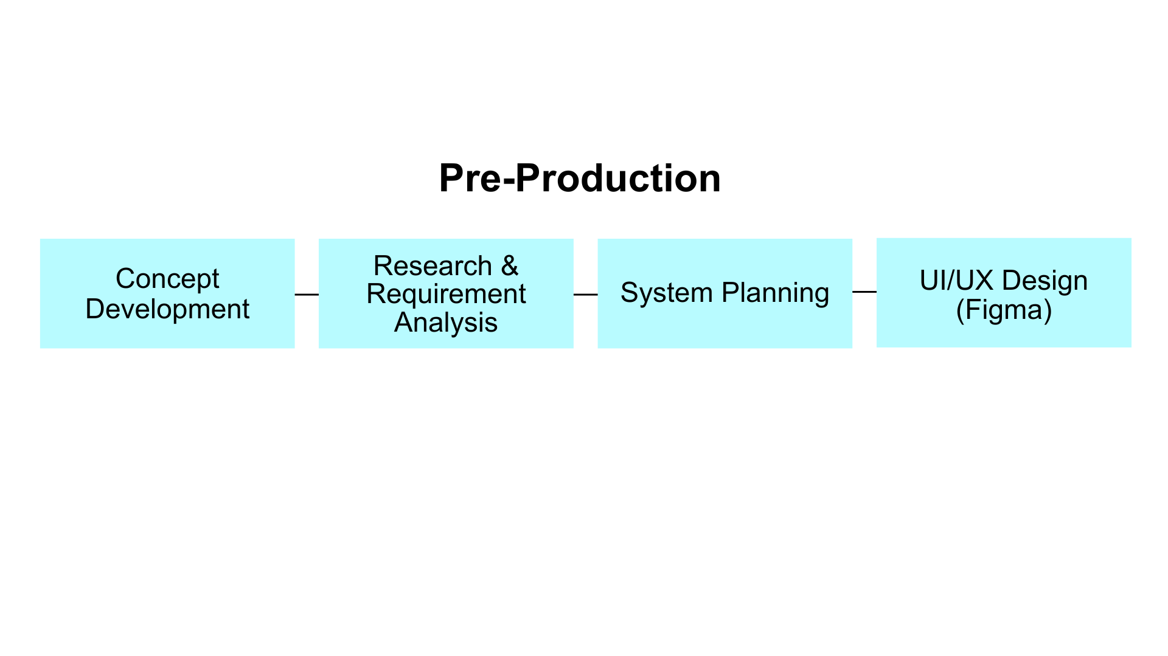
Figure 12. Moodify Pre-production Flow Chart

Before developing Moodify, the developers conducted thorough research and analysis to build a strong foundation for the design, app features, and technical framework of Moodify. Concept development involved the developers defining the purpose of the mood tracking and outlining the key features of the application based on research findings. Research & requirement analysis are essential steps in the development of Moodify. The developers conducted a review study on emotions, emotional regulation, mood tracking, and the needs of an individual to ensure the application's content is accurate and reliable while simultaneously identifying the user and system requirements with the assistance of IT experts and mental health professionals. Their insights improved the system design, user experience, and relevance. For a structured development, system planning was carried out to design the workflow of the application, detailing how users record their mood, answer reflection prompts, receive suggestions, and view mood charts that showcase their emotional trends. This served as a blueprint and guided the developers in developing Moodify, ensuring efficiency. Additionally, Figma was used to design the UI/UX and prototype of the application.

Application Development
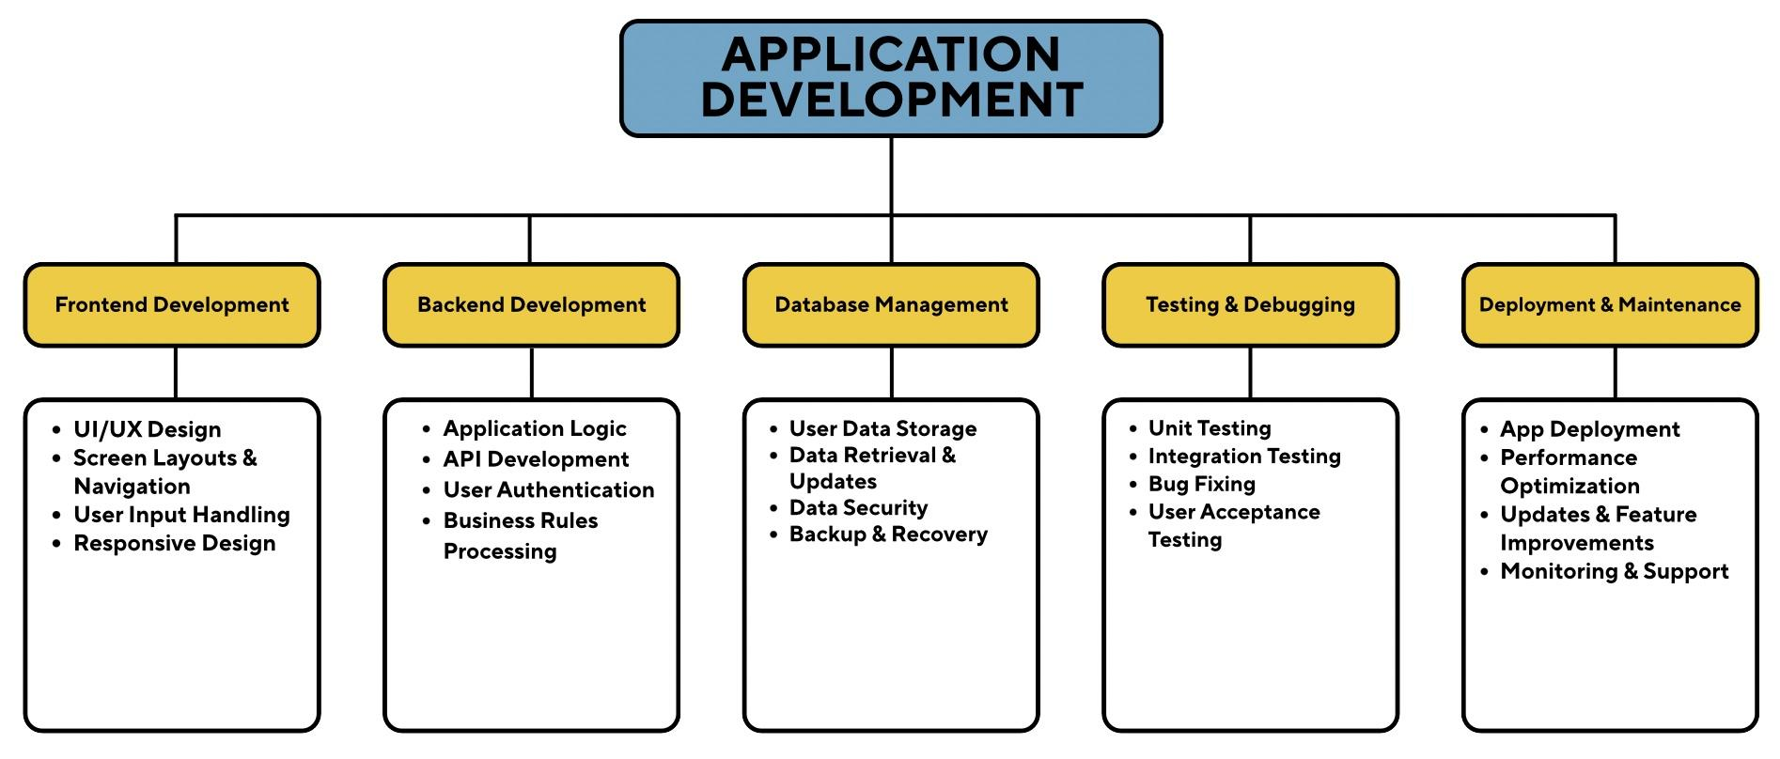
Figure 13. Moodify Application Development Process Flowchart

Frontend Development
This refers to the design and implementation of the user-facing part of the application, the portion that users interact with directly. It focuses on providing intuitive, visually appealing, and functional interfaces that facilitate mood tracking, self-reflection, and emotional regulation. UI/UX design uses a clean, minimal, and calming layout, making it easy for users to navigate and feel comfortable while tracking their moods. Screen layouts and navigation are organized logically, with clear buttons, menus, and a bottom bar, so users can quickly move between mood tracking, journaling, charts, and regulation tools. User input handling allows users to record their moods, answer self- reflection questions, and write journal entries through interactive elements like buttons, checkboxes, and text fields, ensuring accurate and personalized data collection. Responsive design makes sure the app adjusts to different screen sizes and devices, so all features look and work well anywhere, providing a consistent and inclusive experience for every user.

Backend Development
The backend development ensures that only authorized users can access system features by verifying login credentials and managing sessions and access levels such as admin and user roles, protecting accounts and sensitive data from unauthorized use. It also processes business rules by evaluating each request according to predefined conditions, validating transactions, enforcing system restrictions, performing automatic calculations, and generating appropriate system responses. Through this process, the system maintains security, accuracy, and consistent operation.

Database Management
Having a database and its management is crucial to any and all applications, as attributed to the fact that it handles storage, organization, and access to users’ data. The database serves essentially as the central repository for the application’s information, ensuring that data is stored, transferred, accessed, and retrieved efficiently and with speed. This information tells developers that the database’s information and ability is reliable and protected. These steps are taken by ensuring that the users’ information (historical information such as journal entries and moods logged) are preserved over time, and by also ensuring that this data is safeguarded against accidental loss, possible system failures, or file corruption by including data backups and data recovery mechanisms in the database management.

Testing & Debugging
To improve the functionality and overall performance of Moodify, the developers conducted thorough testing and debugging. A systematic test was conducted to identify and eliminate technical issues, ensuring each feature—mood entry, suggestions, mood charts, and self-reflection prompts—operated as intended. Furthermore, these issues were addressed through debugging to isolate and fix coding errors. Additionally, with the IT experts' insights on the application, it was possible to further improve the application's usability and user experience, ensuring it meets the quality standards.

Deployment & Maintenance
The deployment phase of the Moodify system was conducted after the successful completion of system and user acceptance testing. The application was set up and deployed in the target environment, ensuring compatibility with supported devices and operating systems. Deployment tasks included application setup and installation, database setup, data validation, and system connectivity and performance verification. Security features such as access control, data encryption, and secure storage were implemented to safeguard user data during the deployment process. System monitoring tools were used to ensure system stability, availability, and correct functionality of all features. After the deployment process, the maintenance phase involved corrective, adaptive, and preventive maintenance tasks. Corrective maintenance was conducted to address system bugs, errors, and performance problems identified during system usage. Adaptive maintenance was performed to ensure compatibility with platform updates and changing user needs. Preventive maintenance was done through periodic system checks, optimization, and updates to enhance system reliability, security, and overall efficiency.

Source Code
Project Manual

Cost of the Product
Softwares
Fees | Item | Description | Purpose | Unit Price (₱)
 | Validation Fee | A process of verification | Serves as a verification for the assets used in the application | ₱2,500
 | Professional Fee | A token for expert services | Serves as compensation for one’s skill and time | ₱4,000
 | Item | Description | Purpose | Unit Price (₱)
 | Figma | A prototype tool and UI/UX design | To design app layout and user flow | ₱0.00
 | Firebase | A backend platform for apps. | To manage authentication and database | ₱0.00
 | Flutter | A cross-platform development framework | To build the application | ₱0.00
 | Git | Version control system | To track and manage coding | ₱0.00
 | Github | Online Git repository platform | To store code and enable collaborations | ₱0.00
 | Android Studio | An Android development Integrated development environment (IDE) | To test and debugs the app | ₱0.00
Hardware | Item | Description | Purpose | Unit Price (₱)
 | Computer | Existing personal devices | Used for development and testing | ₱ 0.00
 |  |  | TOTAL: | ₱ 6,500

Table 6. Cost of Moodify

Table 6 is divided into 3 main sections: a) Fees, b) software, and c) Hardware with each thoroughly discussing the product description, purpose, and unit price.

The first component, which includes the Validation Fee and Professional Fee, has a total cost of Php 6,500.00. Which covers both professional services and necessary validations. The Validation fee of Php 2,500.00 is allocated for verifying the assets used in the application, ensuring that all components meet the required standards. The Professional Fee of Php 4,00.00 is set aside as compensation for the skills and time invested by the developers and experts involved in the project, providing guidance throughout the development process and ensuring the app is functional, user-friendly, and effective in mood and emotion tracking.

The second component encompasses the software used in the development of Moodify, including Figma, Firebase, Flutter, Git, Github, and Android studio, all of which have a total cost of Php 0.00. The tools offer basic functions which enable users to design their interface and user flow, handle backend tasks, create applications for multiple platforms, monitor code modifications, keep code in online storage, and conduct application testing and debugging. The developers used the free versions of these tools to achieve their resource optimization goals while delivering high-quality work and efficient results.

The third component covers hardware, which in this project refers to the developers’ existing personal computers/laptop used for development and testing. The existing devices provided essential support for the application development process because they eliminated the need for new purchases. The project budget demonstrates precise fund distribution, which finances professional services and validation work, while the project uses free software together with existing hardware to achieve functional, reliable operations of Moodify at minimal cost.

Project Cost Analysis
The project cost analysis exists to evaluate Moodify’s financial feasibility and practicality as a capstone research project. This analysis seeks to determine whether the project cost is reasonable in relation to our research team’s scope, objectives, and benefits of the system we seek to achieve with Moodify. By examining the necessary financial expenses that the development and deployment of Moodify requires, the researchers seek to justify that the benefits of Moodify outweigh its costs, and the system can be developed and deployed with minimal financial resources yet yielding more than optimal efficiency.
The total cost of Moodify’s development amounts to roughly ₱6,500, its relative frugality is attributed to mainly allocating the costs for validation and professional fees, as well as utilizing free and open-source software tools and pre-existing hardware resources. These expenses were meticulously planned to ensure that the system’s development remains cost-efficient while more importantly, meets academic, ethical, and technical standards.There are two main expenses that contribute to most of the funding requirements for the development of Moodify, validation fees and professional fees. Validation fees represent costs related to verifying assets, materials, and most content used in the application, ensuring that the app’s key features and content are accurate, appropriate, and aligned with the study’s objectives. The professional fees cover compensation for expert services rendered during the production of the app, expenses such as professional guidance, technical expertise, and the valuable feedback professional consultations come with. The professional fees reflect the value that experts’ inputs contribute to the overall strengthening of the application’s design, development, data handling, and evaluation.
In terms of software development costs, Moodify has opted to utilize development tools such as Flutter, Firebase, Figma, Git, Github, and Android Studio, all of which come with no monetary cost. These tools were selected as the main modems for development as they are reliable, widely used, and are industry-standard in mobile application development.
All in all, the project demonstrates secure financial feasibility, as the total development cost is low compared to similar mobile application projects while still maintaining the ability to deliver the app’s intended purpose.

 | Moodify | Product 1 | Product 2
Components
Manufacturing | ₱ 0.00 | ₱≤30,000.00 | ₱≤54,000.00
Validation Fee | ₱ 2,500.00 | - | -
Professional Fee | ₱ 4,000.00 | ₱≤20,000.00 | ₱≤150,000.00
Total Cost | ₱6,500.00 | ₱≤200,000.000 | ₱≤324,000.00
Cost Difference to the Moodify | 0.00% | ≤140.94% | ≤161.36%
Table 7. Project Cost Analysis
The table compares the development cost of the capstone research project with two commercially available applications, namely Headspace and Calm. The study developed Moodify as its product, while Headspace and Calm function as popular mental health and well-being applications which enable users to track their moods and control their emotions. The selected applications were used to determine whether Moodify would generate financial value when compared to existing products which customers can buy in the market. The compared applications did not reveal their actual production expenses, but the cost estimates were developed through software cost estimation methods which previous research established, and which mobile application cost analysis studies proven (Jaiswal et al., 2024).
Moodify offers more cost-effective development expenses than both Headspace and Calm because it delivers lower expenses for creating its software products. The development team worked with experts to create their software products by using free and open-source software tools which led to lower production expenses. The team developed the application by using all available features of the software tools which resulted in success for its complete operation and dependable performance and user-friendly design.
The direct costs of Moodify show that manufacturing expenses created 0.00% of total project expenses because the project used free distribution platforms without needing to pay for server hosting during development. The system validation fee represented 38.46% of total project expenses because it included system feature evaluation and functional verification costs. The professional fee made up 61.54% of total project expenses. Moodify achieved cost savings because it used development tools and resources which are available without charge, in contrast to Headspace and Calm which face higher expenses because they require paid software licenses and subscription-based systems and increased production costs.
The project costs show a distinct financial difference after experts evaluated all direct expenses. Moodify development costs show a cost difference which is ≤140.94% lower than Headspace and ≤161.36% lower than Calm according to existing market products. Moodify operates as a cost-effective application because it uses resource management, extensive research, free software, and professional consultation to deliver a user-centered mental health support system.

References
Abbacus Technologies. (2021). Flutter Cross-Platform App Development: Benefits & Use Cases. https://www.abbacustechnologies.com/flutter-cross-platform-app-development-benefits-use-cases/
Adigun, F. & Adelusi, J. B. (2024). Using Wearable Devices and AI for Real-Time Mood Monitoring.
Alfahri, D. A. & Widarma, A. (2025). Implementation of Flutter and Firebase in Developing a Mobile News Portal Application. Bigint Computing Journal, 3(1), 50-58. https://doi.org/10.55537/bigint.v3i1.1083
Alkhawaldeh, A. et al. (2023). Stress Factors, Stress Levels, and Coping Mechanisms among University Students. The Scientific World Journal, 2023(2026971). https://doi.org/10.1155/2023/2026971
Arifin, S. & Maharani, L. (2021). Assessing User Experience of a Mobile Application Using Usability Questionnaire Method. Applied Information System and Management (AISM). 4. 1-10. https://doi-org/10.15408/aism.v4i1.20265.
Askarizadeh, M.M. et al. (2025). Determining the impact of mobile-based self-care applications on reducing anxiety in healthcare providers: a systematic review. BMC Med Inform Decis Mak, 25, 37. https://doi.org/10.1186/s12911-024-02817-4
Amazon Web Services. (n.d.). What is Flutter? Amazon Web Services, Inc. https://aws.amazon.com/what-is/flutter/
Bakker, D. & Rickard, N. (2018). Engagement in mobile phone app for self-monitoring of emotional wellbeing predicts changes in mental health: MoodPrism. Journal of Affective Disorders, 227, 432-442. https://doi.org/10.1016/j.jad.2017.11.016.
Beedie, C. J., Lane, A. M., Udberg, R., & Terry, P. C. (2022). The 4R Model of Mood and Emotion for Sustainable Mental Health in Organisational Settings. Sustainability, 14(18), 11670. https://doi.org/10.3390/su141811670
Bhandari, P. (2020) An Introduction to Quantitative Research. https://www.scribbr.com/methodology/quantitative-research
Białkowski, D. & Smołka, J. (2022). Evaluation of Flutter framework time efficiency in context of user interface tasks. Computer Science Institute, 309-314.
Caldeira, C. et al. (2018). Mobile apps for mood tracking: an analysis of features and user reviews. AMIA Annual Symposium proceedings. AMIA Symposium, 2017, 495–504. https://doi.org/10.2196/29368
Catani, S. et al. (2015). Systems and methods for wellness, health, and lifestyle planning, tracking, and maintenance. US010614724B2 United States Patent.
Chen, X. et al. (2018). What about Mood Swings: Identifying Depression on Twitter with Temporal Measures of Emotions. In Companion Proceedings of the The Web Conference 2018 (WWW '18). International World Wide Web Conferences Steering Committee, Republic and Canton of Geneva, CHE, 1653–1660. https://doi.org/10.1145/3184558.3191624
Cohen, R. et al. (2023). System and method of monitoring mental health conditions. US20230091240A1 United States Patents
Daniela, G. (2024). Supporting Developers' Emotional Awareness: from Self-reported Emotions to Biometrics. Association for Computing Machinery, New York, NY, United States, 500–504. https://doi.org/10.1145/3661167.3661209.
Darcy, A. M., & Jacobson, S. (2023). Emotional awareness – what it is and why you need it. Harley TherapyTM Blog. https://www.harleytherapy.co.uk/counselling/emotional-awareness.htm
Dinç, E., Wherley, M. S., & Sankey, H. (2023). Student perception of journaling as an assessment for an engagement experience. Journal of Experiential Education, 47(3). https://doi.org/10.1177/10538259231203671
Dubad, M., Elahi, F., & Marwaha, S. (2021). The Clinical Impacts of Mobile Mood-Monitoring in Young People With Mental Health Problems: The MeMO Study. Frontiers in psychiatry, 12, 687270. https://doi.org/10.3389/fpsyt.2021.687270
Eisenstadt, M. et al. (2021). Mobile Apps That Promote Emotion Regulation, Positive Mental Health, and Well-being in the General Population: Systematic Review and Meta-analysis. JMIR Ment Health, 8(11). https://doi.org/10.2196/31170
Em, S. (2024). Exploring Experimental Research: Methodologies, Designs, and Applications Across Disciplines. SSRN. https://dx.doi.org/10.2139/ssrn.4801767
Fleming, T. B. et al. (2018). Beyond the Trial: Systematic Review of Real-World Uptake and Engagement with Digital Self-Help Interventions for Depression, Low Mood, or Anxiety. J Med Internet Res, 20(6). https://doi.org/10.2196/jmir.9275
Ford, B. & Mauss, I. B. (2026). Emotion Experience and Well-being. In R. Biswas-Diener & E. Diener (Eds), Noba textbook series: Psychology. Champaign, IL: DEF publishers. Retrieved from http://noba.to/uk6dvwyf
Gustman, S. et al. (2021). Method and Apparatus for Mood Based Computing Experience. (U.S. Patent No. 202100116114A1). U.S. Google Patents. https://patents.google.com/patent/US20210011614A1
Hamre-Os, A. (2021). A Mood Tracking Interface for Mobile Application -to Help Assess Well Being in Students. Universitetet i Bergen. https://hdl.handle.net/11250/2764323
Insights Success Magazine. (2025). Information Technology in the Philippines Today 2025. https://insightssuccessmagazine.com/information-technology-in-the-philippines-today/
Jaiswal, A. et al. (2024). Software cost estimation tool: A App based application, estimate the cost of software project. Computing and Artificial Intelligence, 2(2), 1364. https://doi.org/10.59400/cai.v2i2.1364
Jošt, G., & Taneski, V. (2025). State-of-the-Art Cross-Platform Mobile Application Development Frameworks: A Comparative Study of Market and Developer Trends. Informatics, 12(2), 45. https://doi.org/10.3390/informatics12020045
Kauer S. D. et al. (2012). Self-monitoring using mobile phones in the early stages of adolescent depression: randomized controlled trial. J Med Internet Res, 14(3):e67. https://doi.org/10.2196/jmir.1858. PMID: 22732135
Khomo, H. & Mulepa, J. E. (2024). Mood and Emotion Tracking App for Individuals with Mental Health Challenges Using IoT. International Journal of Research Publication and Reviews, 5(11), 4270-4273.
Miller, M. & Olsson, A. T. (2022). Emotions, Feelings, & Moods: What's the Difference and Why it Matters. sixseconds. https://www.6seconds.org/2022/07/15/emotion-feeling-mood/
Montemayor, M. T. (2025). Experts Urge Filipinos to Prioritize Mental Health, Fight Stigma. Philippine News Agency. https://www.pna.gov.ph/articles/1262277?
Moors, A. (2017). Appraisal Theory of Emotion. https://doi.org/10.1007/978-3-319-28099-8_493-1.
Moskowitz, M. P. (2021). Mood tracking and delivery of a therapeutic based on Emotional or Mental State of a User. US20210169389A1 United States Patents.
Mneime, M. (2020). Emotions, Moods, Conditioning, and the Brain. The Albert Ellis Institute. https://albertellis.org/2013/03/emotions-moods-conditioning-and-the-brain/
Mwakiseghire, M. & Jimu, P. (2024). MENTAL HEALTH SUPPORT APP WITH MOOD TRACKING AND RESOURCES. i-Manager's Journal on Mobile Applications & Technologies, 11(1), 5. https://doi.org/10.26634/jmt.11.1.20662
Özel, T. K. & Alkar, O. Y. (2026). The vulnerable attachment style as a predictor of depression and stress: The mediating role of emotion regulation and coping strategies. Klinik Psikoloji Dergisi, Advanced Online Publication. https://doi.org/10.57127/kpd.26024438.1681669
Ratcliffe, M. (2013). Why Mood Matters. The Cambridge Companion to Heidegger's Being and Time, pp. 157-176. Cambridge University Press. https://doi.org/10.1017/CCO9781139047289.008
Reynard, S. et al. (2022). Digital Interventions for Emotion Regulation in Children and Early Adolescents: Systematic Review and Meta-analysis. JMIR Serious Games, 10(3). https://doi.org/10.2196/31456
Rupapara, A. (2019). Flutter App Development: The Trending Cross-Platform Mobile App Development Framework. ICODERZ. https://www.icoderzsolutions.com/blog/flutter-app-development/
Sarraf, Z. (2025). What's Missing in Today's Mobile Apps — And Can You Build It?. Writers. https://vocal.media/writers/what-s-missing-in-today-s-mobile-apps-and-can-you-build-it
Schueller, S. M. et al. (2021). Understanding People's Use of and Perspectives on Mood-Tracking Apps: Interview Study. JMIR Ment Health, 8(8). https://doi.org/10.2196/29368
Schueller, S. M. et al. (2018). Discovery of and Interest in Health Apps Among Those With Mental Health Needs: Survey and Focus Group Study. J Med Internet Res, 20(6), e10141. https://doi.org/10.2196/10141.
Scott, M. T. (2022). Application with Mood Recognition, Tracking, and Reactions. US20220012475A1 United States Patents.
Senette, C., Buzzi, M. C., & Paratore, M. T. (2022). Self-assess Momentary Mood in Mobile Devices: a Case Study with Mature Female Participants. Cornell University. https://doi.org/10.48550/arXiv.2211.01015
Shahzad, M. et al. (2021). Understanding Prevalence and Association of Suicidal Ideation, Deliberate Self- Harm, Stress, Anxiety Depression, and Mood Swings in Pakistan University Students: A Multilevel Analysis. https://doi.org/10.53107/nnjp.v1i2.12.
Sonawane, S. (2025). Exploring the Benefits of Flutter for Cross-Platform App Development. Flutternest. https://flutternest.com/blog/flutter-for-cross-platform-app-development
Strba, M. (2024). Usability Testing Studies: How Many Participants? UXtweak. https://blog.uxtweak.com/usability-studies-how-many-participants-are-enough/
Szypelow, B. (2024). Why Is Flutter a Good Choice for Cross-Platform Projects?. netguru. https://www.netguru.com/blog/flutter-for-cross-platform-app-development
Tajik, O. et al. (2024). Purposive Sampling. IJELS, 2(2).
Thomson, A. et al. (2025). Self-directed digital interventions for the improvement of emotion regulation - acceptability and feasibility for adolescents: systematic review. BJPsych open, 11(6), e270. https://doi.org/10.1192/bjo.2025.10888
Torous, J. et al. (2018). Clinical review of user engagement with mental health smartphone apps: evidence, theory and improvements. Evidence-based mental health, 21(3), 116–119. https://doi.org/10.1136/eb-2018-102891
World Health Organization. (2021). Prevention and Management of Mental Health Conditions in the Philippines: The Case for Investment. https://www.undp.org/philippines/publications/prevention-and-management-mental-health-conditions-philippines-case-investment
World Health Organization. (2022). World Mental Health Report: Transforming mental health for all. World Health Organization. https://www.who.int/teams/mental-health-and-substance-use/world-mental-health-report?
World Health Organization. (2023). DOH and WHO launch the Philippine Council for Mental Health strategic framework 2024–2028. https://cdn.who.int/media/docs/default-source/mental-health/mental-health-atlas-2020-country-profiles/phl.pdf?sfvrsn=45d0ca2b_5%26download%3Dtrue
You, D. & Hu, Mi. (2021). A Comparative Study of Cross-platform Mobile Application Development. Whitireia Polytechnic.

